Enterprise Cloud Computing COM7333 (AZ-900)

AZ-900T00-A Introduction to Microsoft Azure: Hands-on Labs

**Lab 1** [**Create an Azure resource**](https://msle.learnondemand.net/Lab/54709?instructionSetLang=en&classId=712625)

Login to Azure

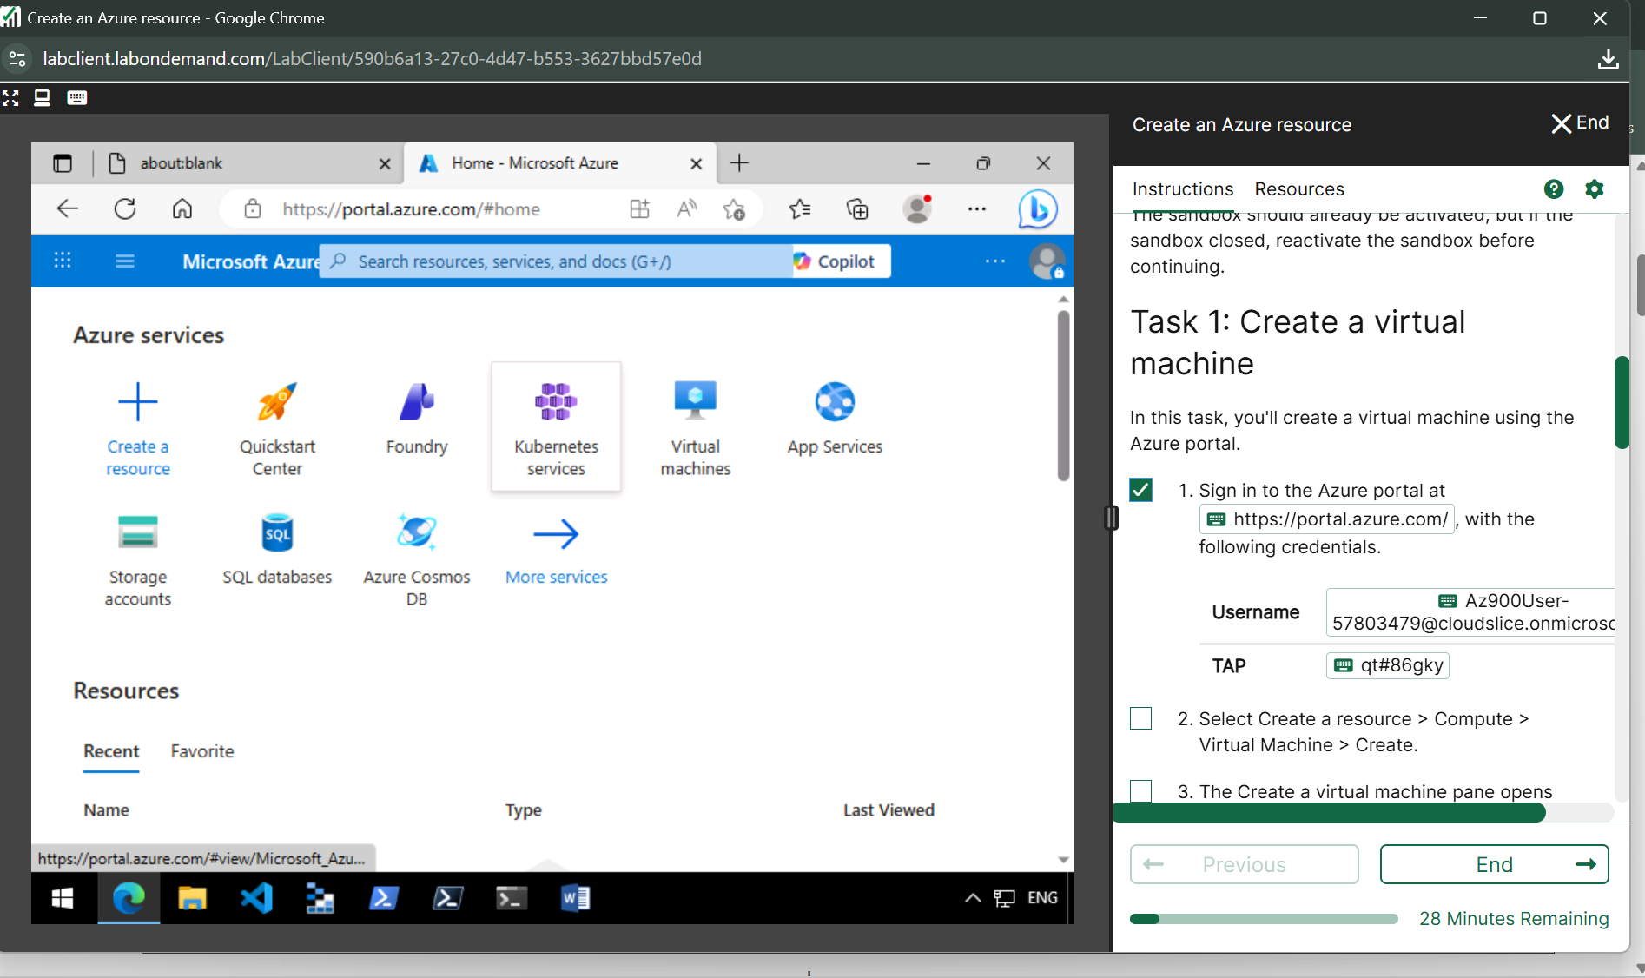

Create virtual machine

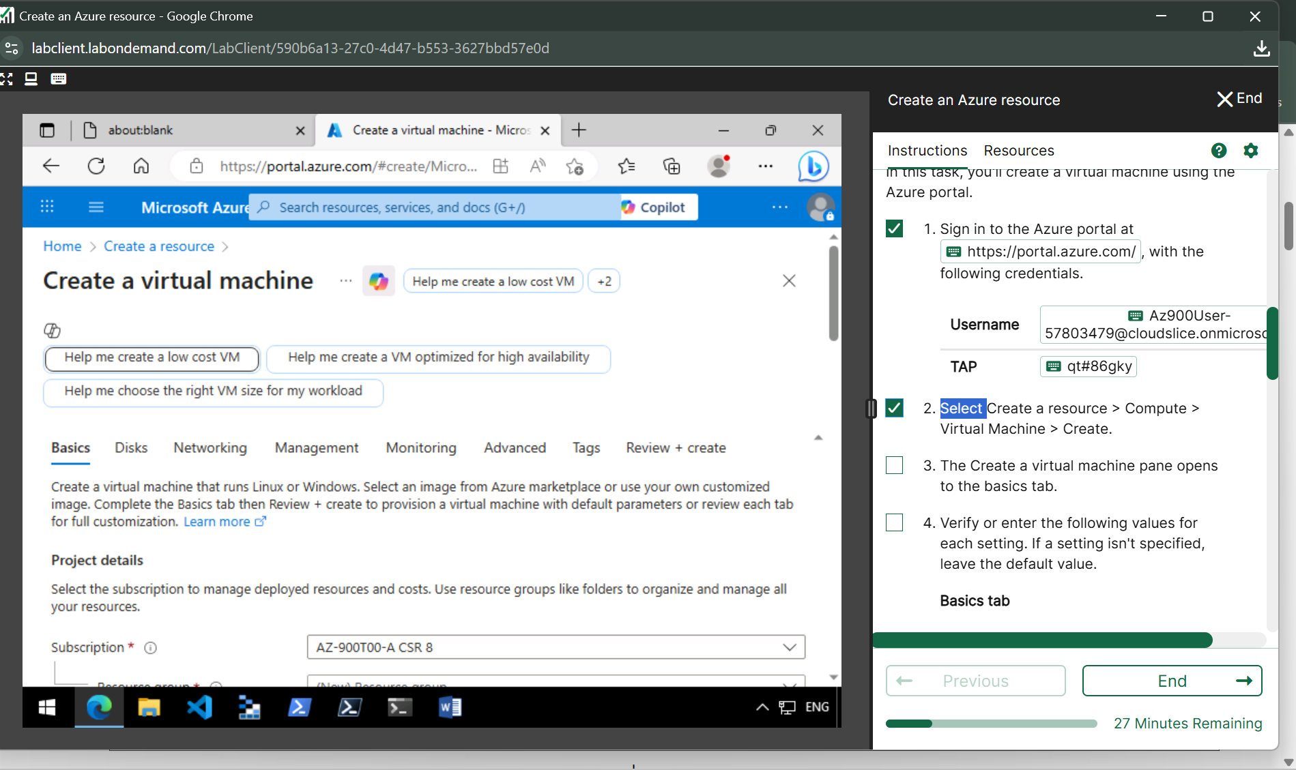

Selecting VM size

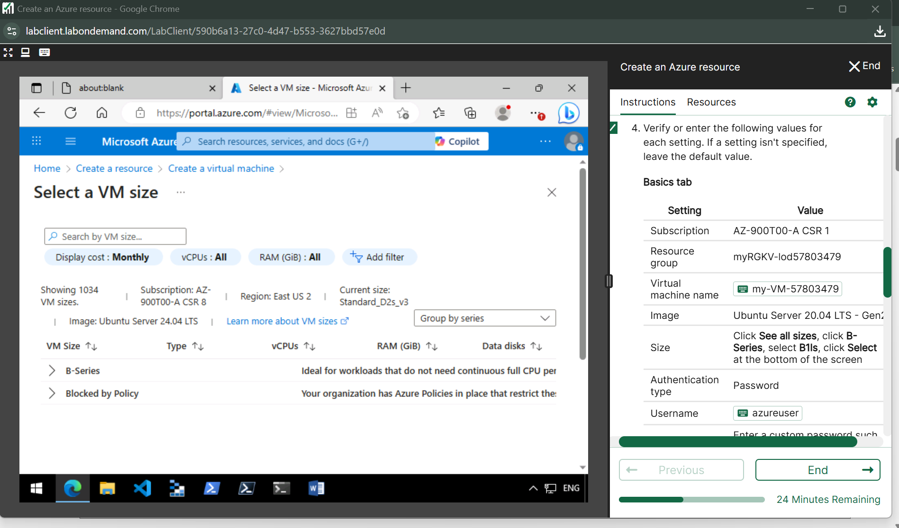

Authentication

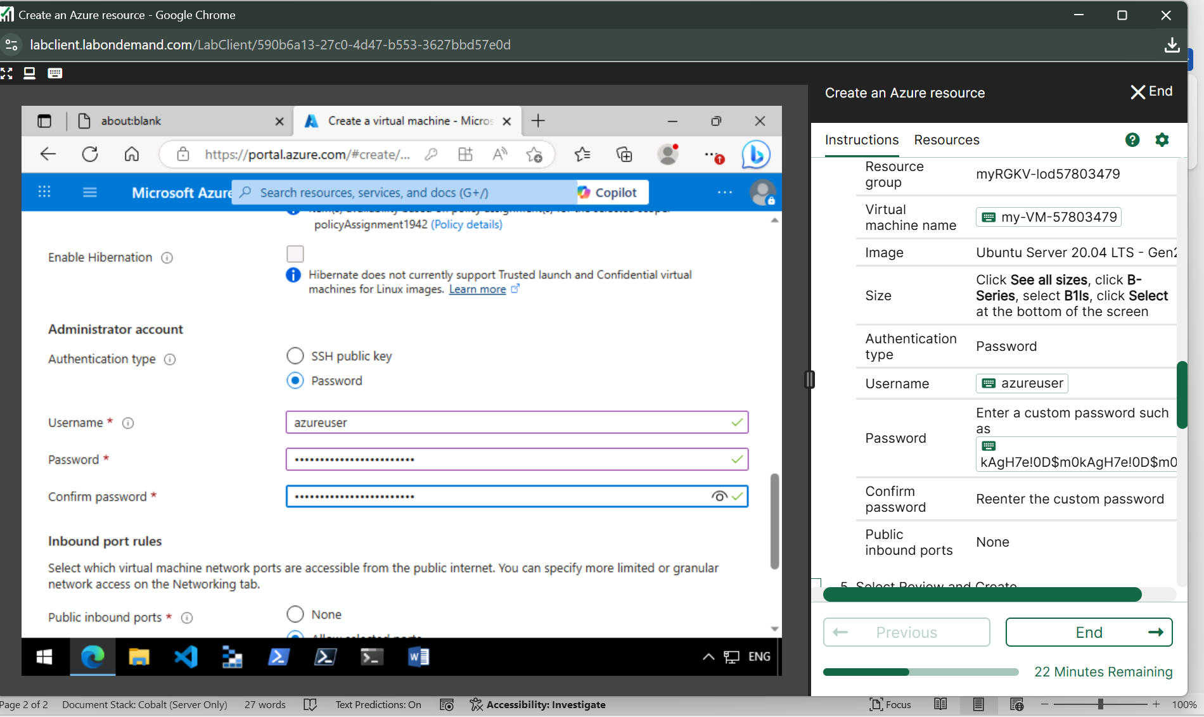

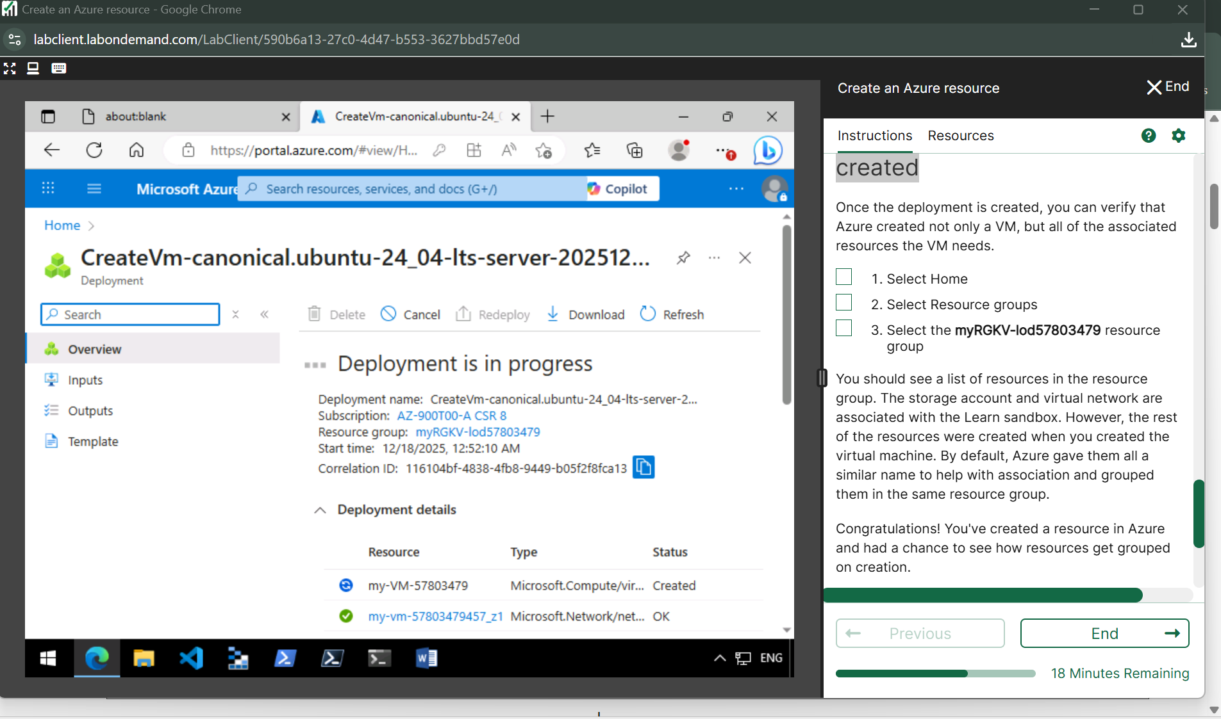

**Verify resources created**

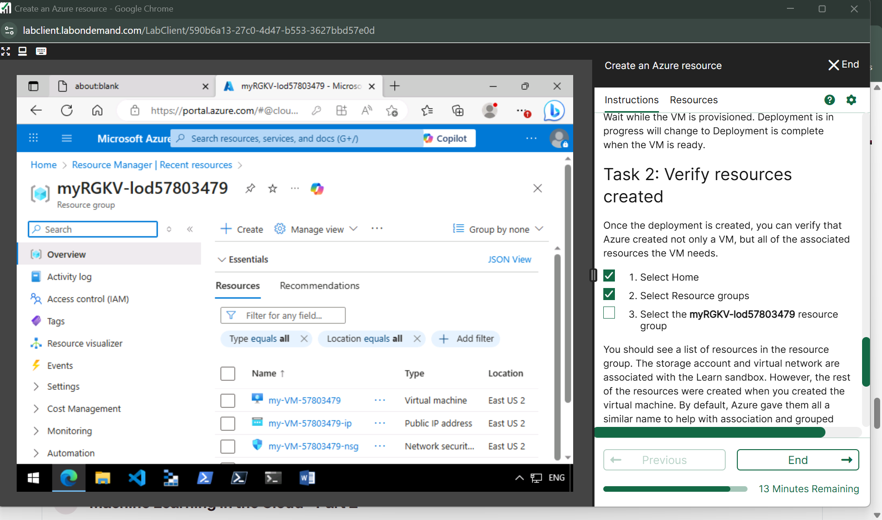

**LAB 2** [**Create an Azure Virtual Machine**](https://msle.learnondemand.net/Lab/54710?instructionSetLang=en&classId=712625)

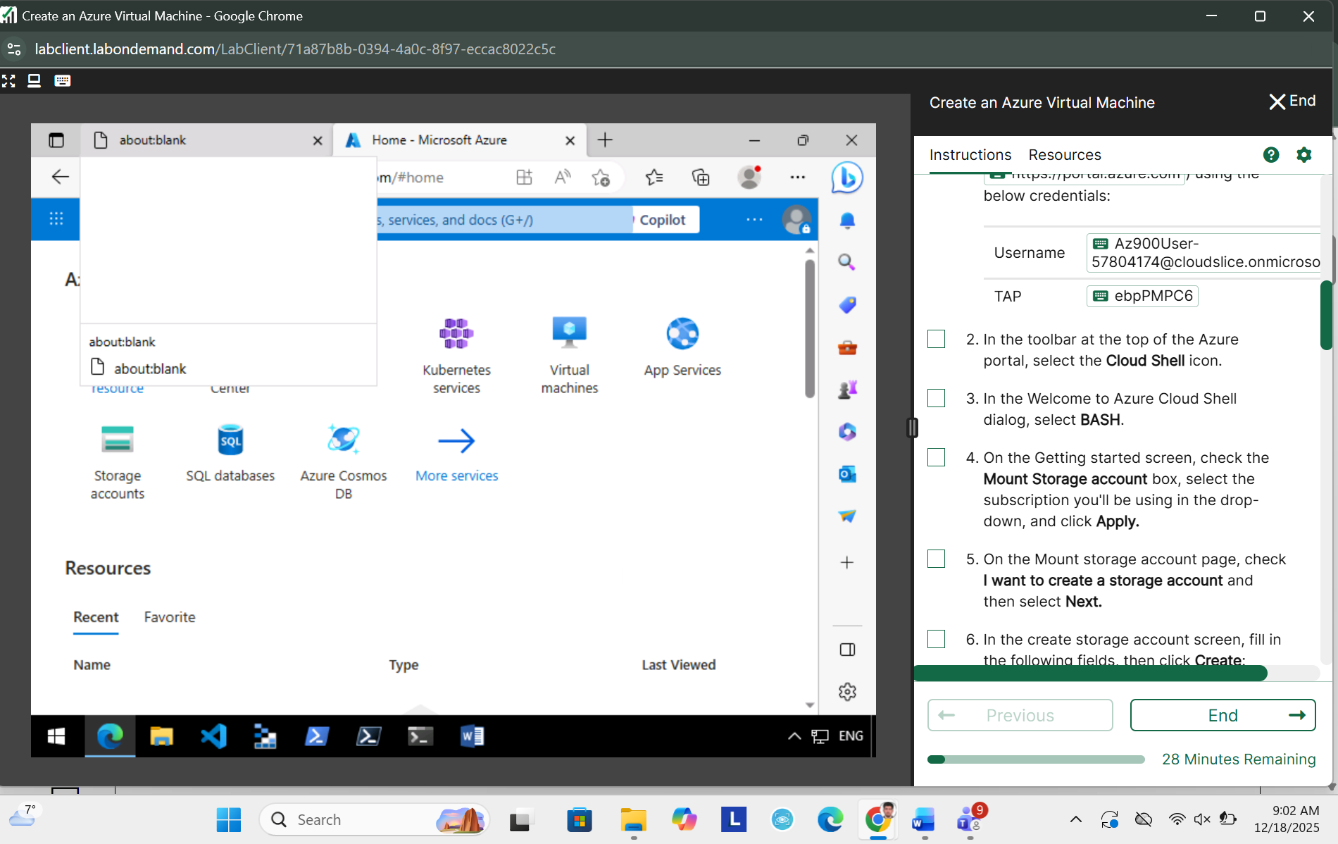

**Cloud Shell**

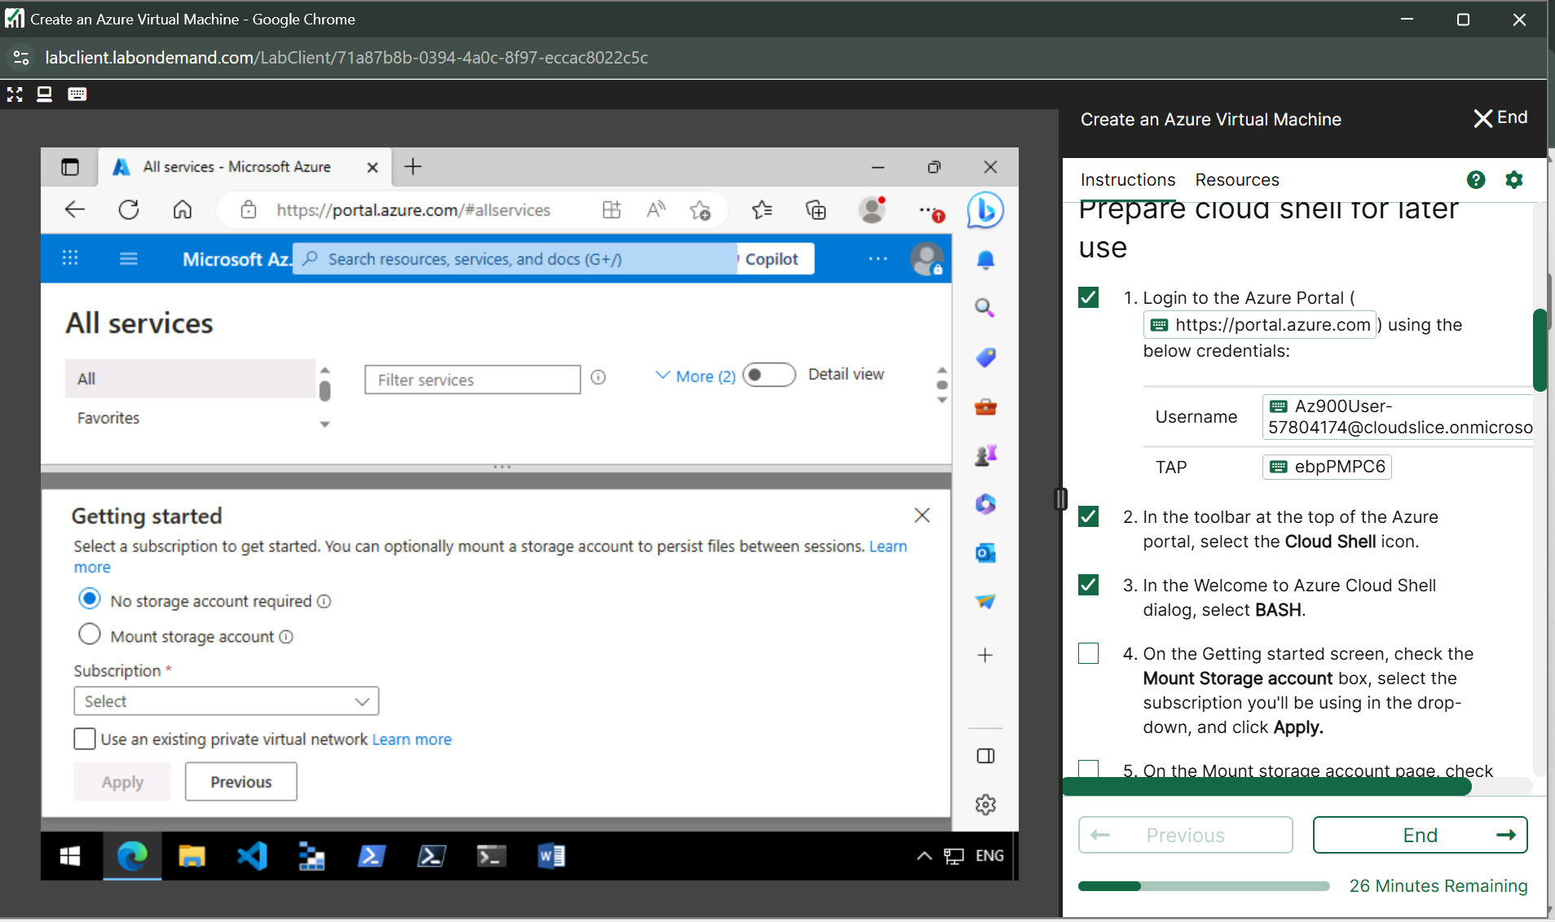

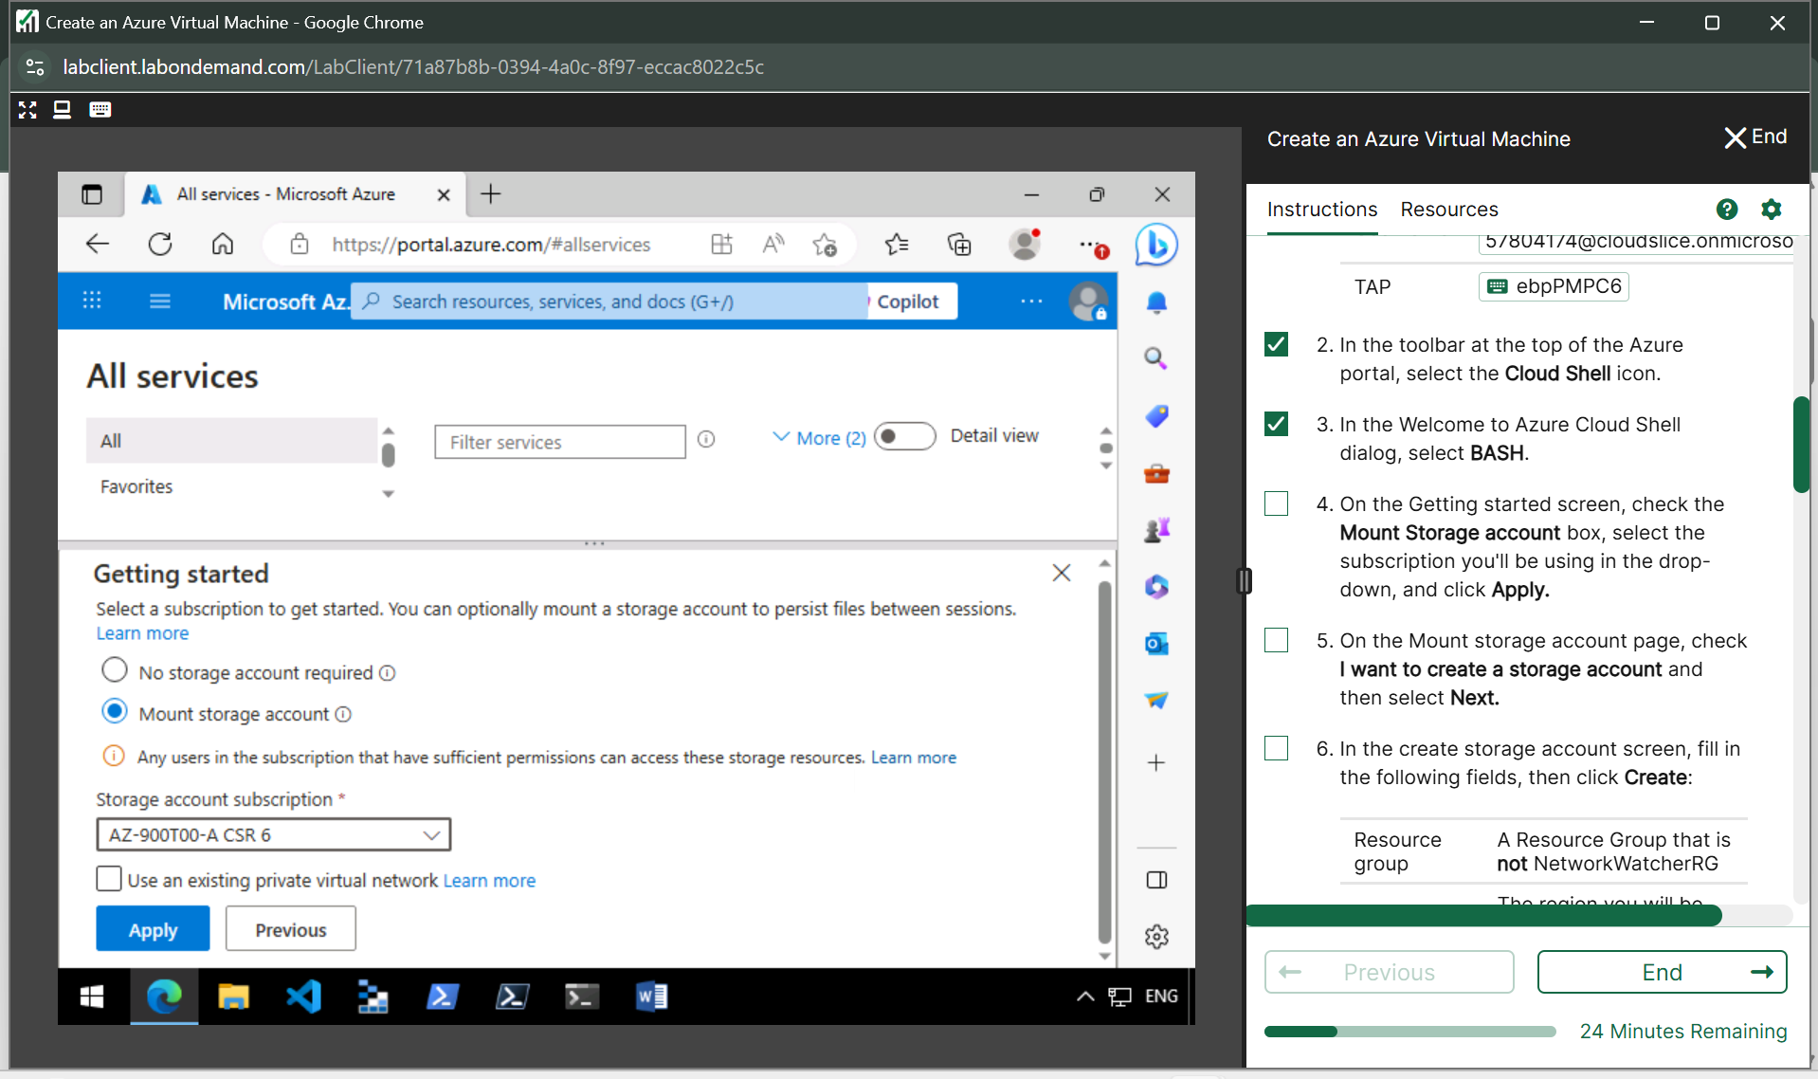

**Create storage account**

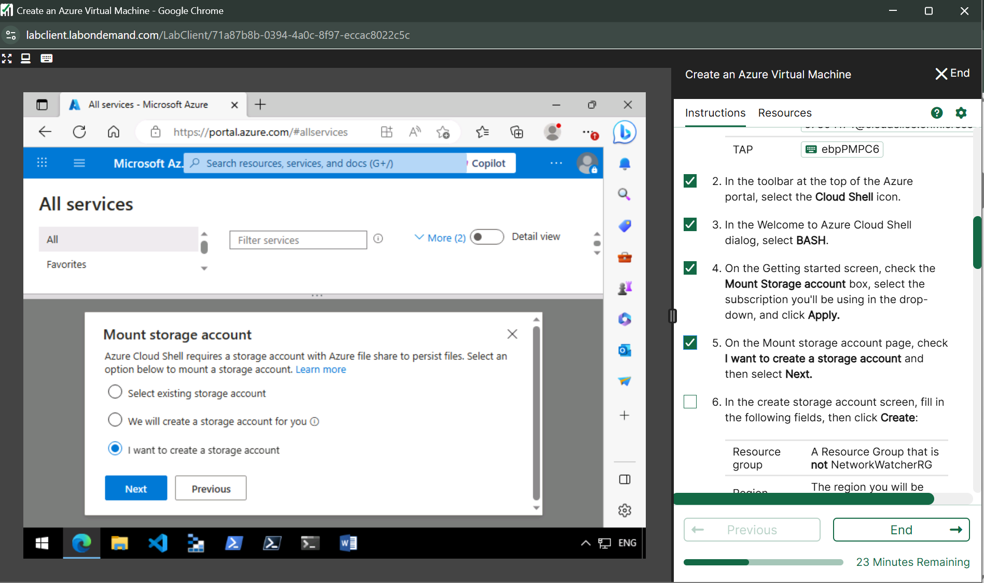

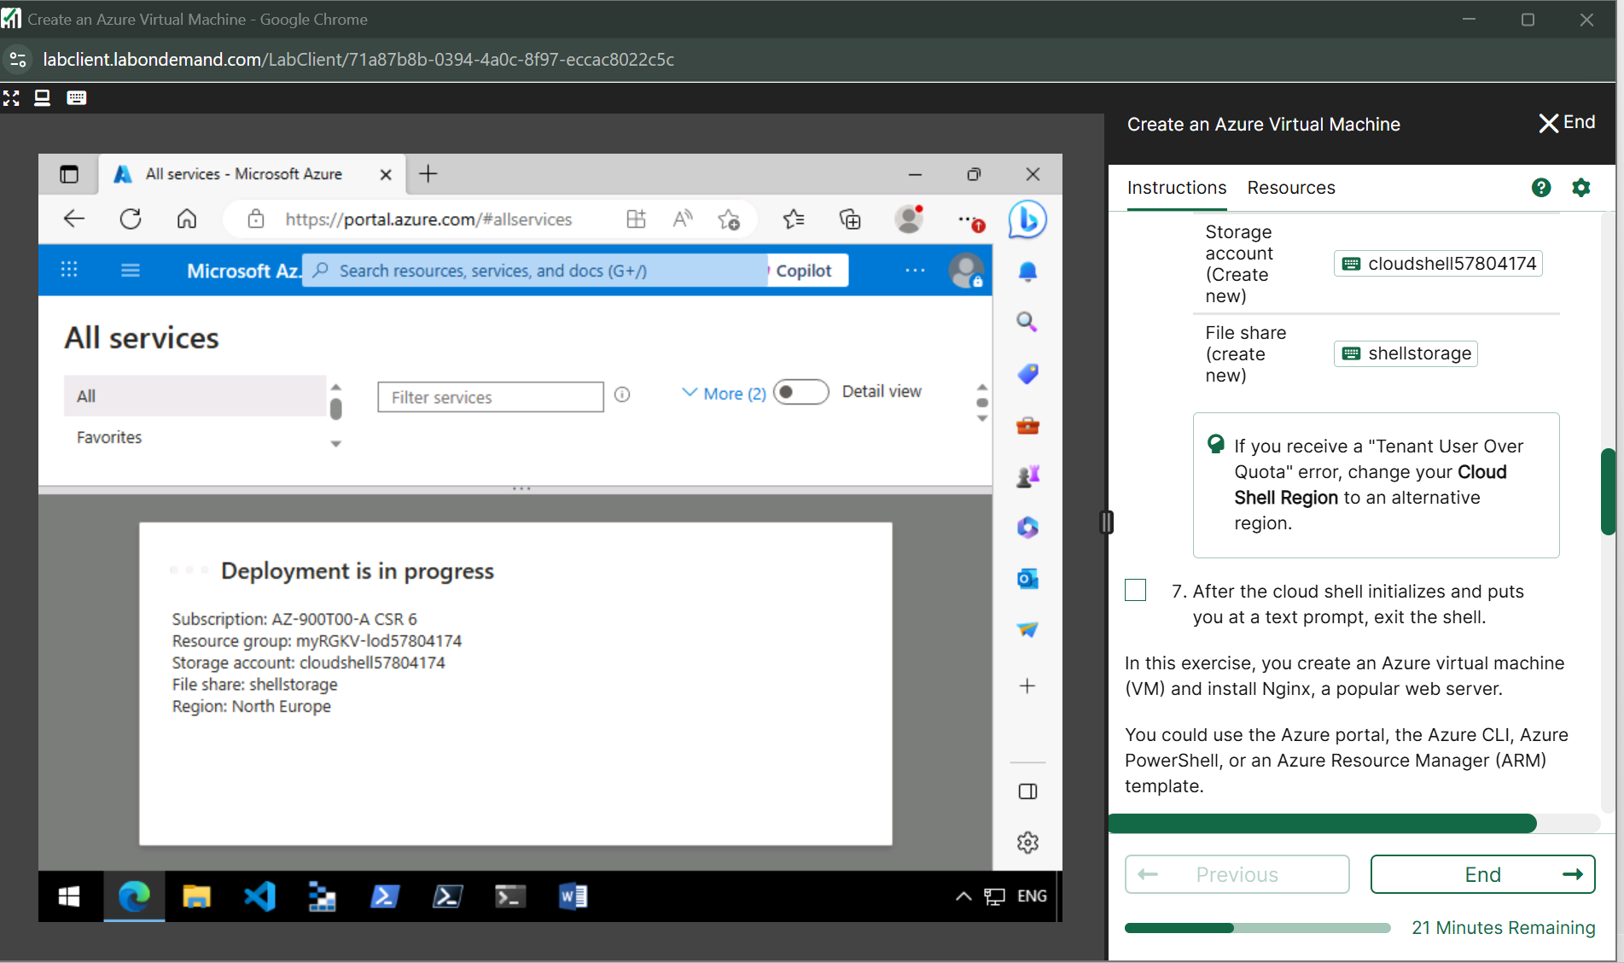

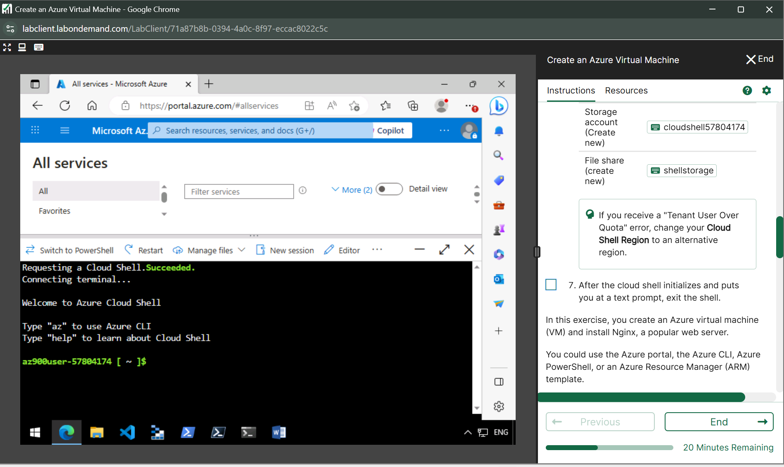

**Task 1: Create a Linux virtual machine and install Nginx  
From Cloud Shell, run the following az vm create command to create a Linux VM:**

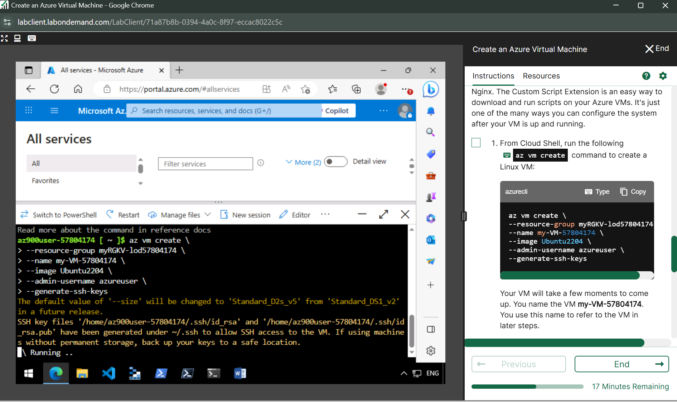

**Run the following az vm extension set command to configure Nginx on VM**

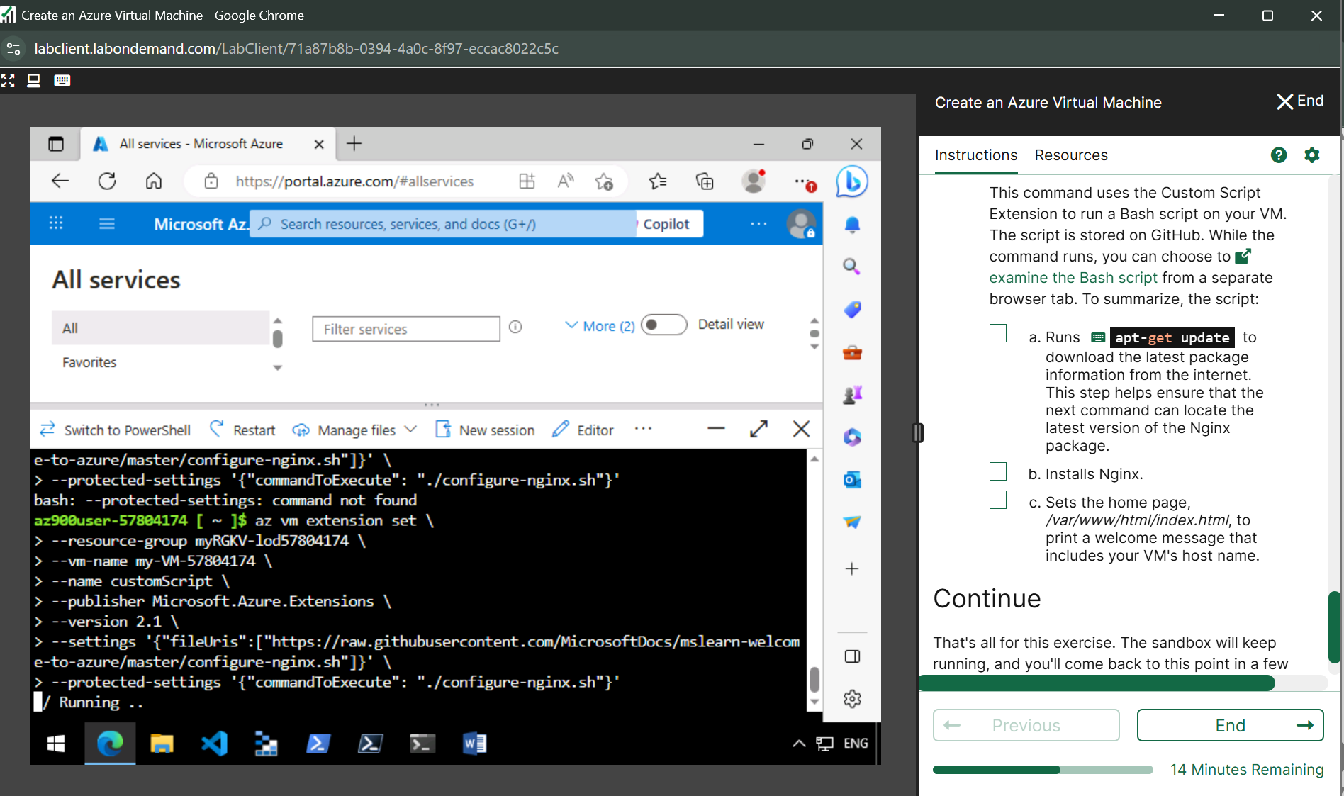

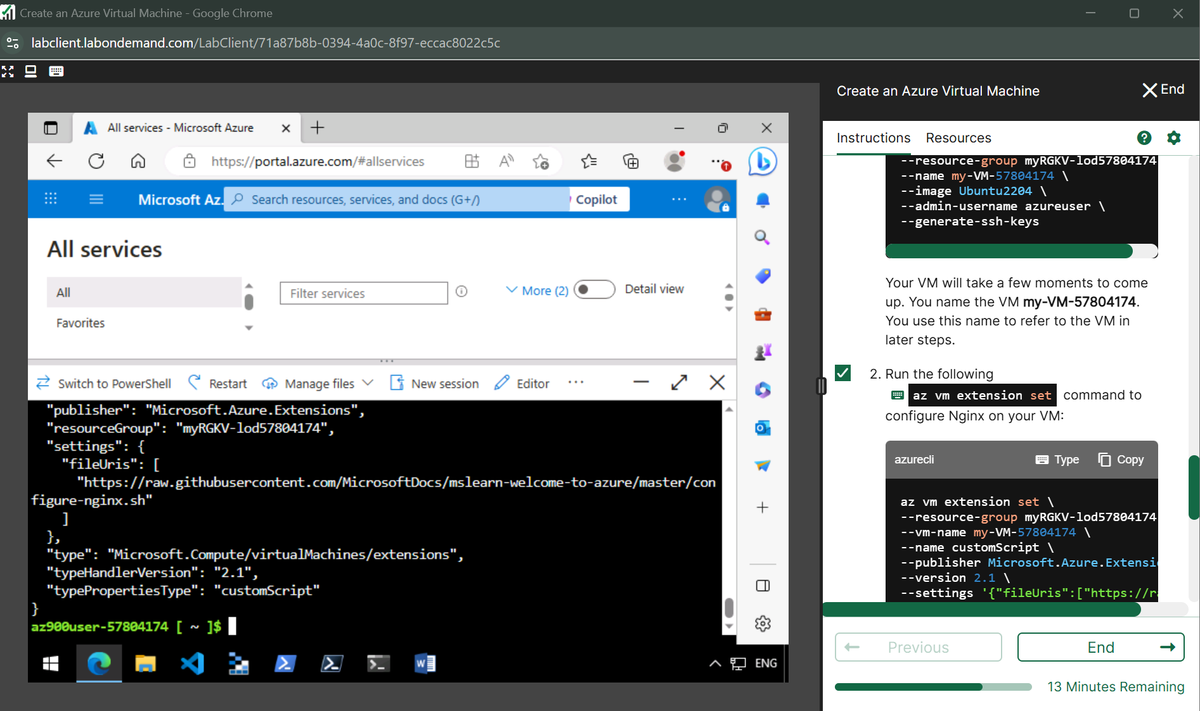

**Lab 3** [**Configure network access**](https://msle.learnondemand.net/Lab/54712?instructionSetLang=en&classId=712625)

**Cloud Shell**

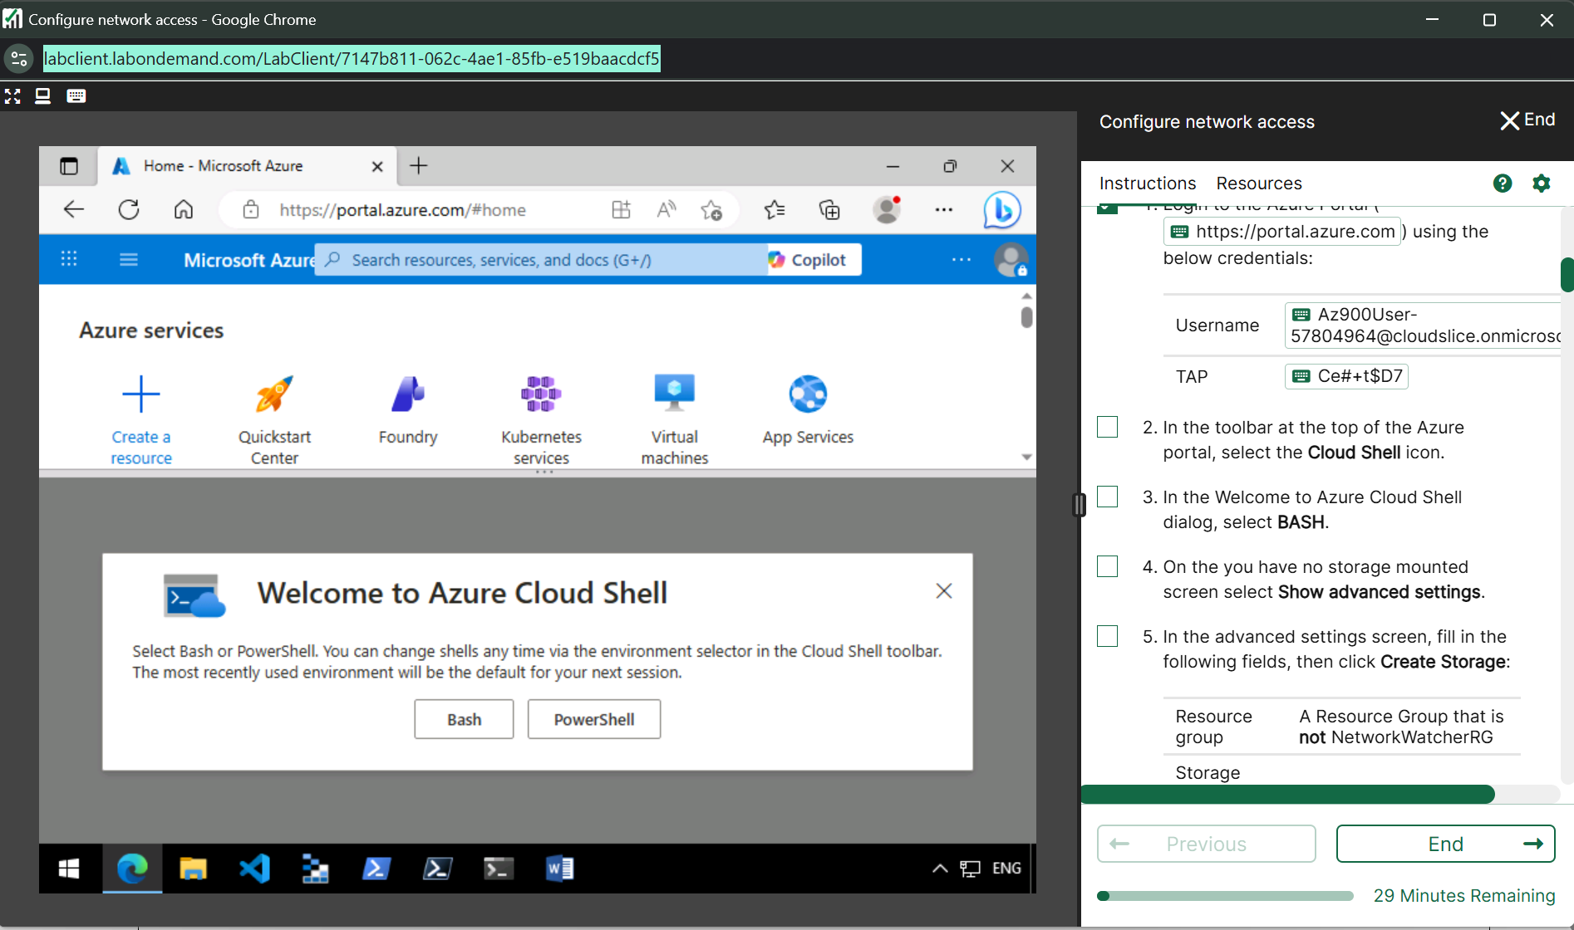

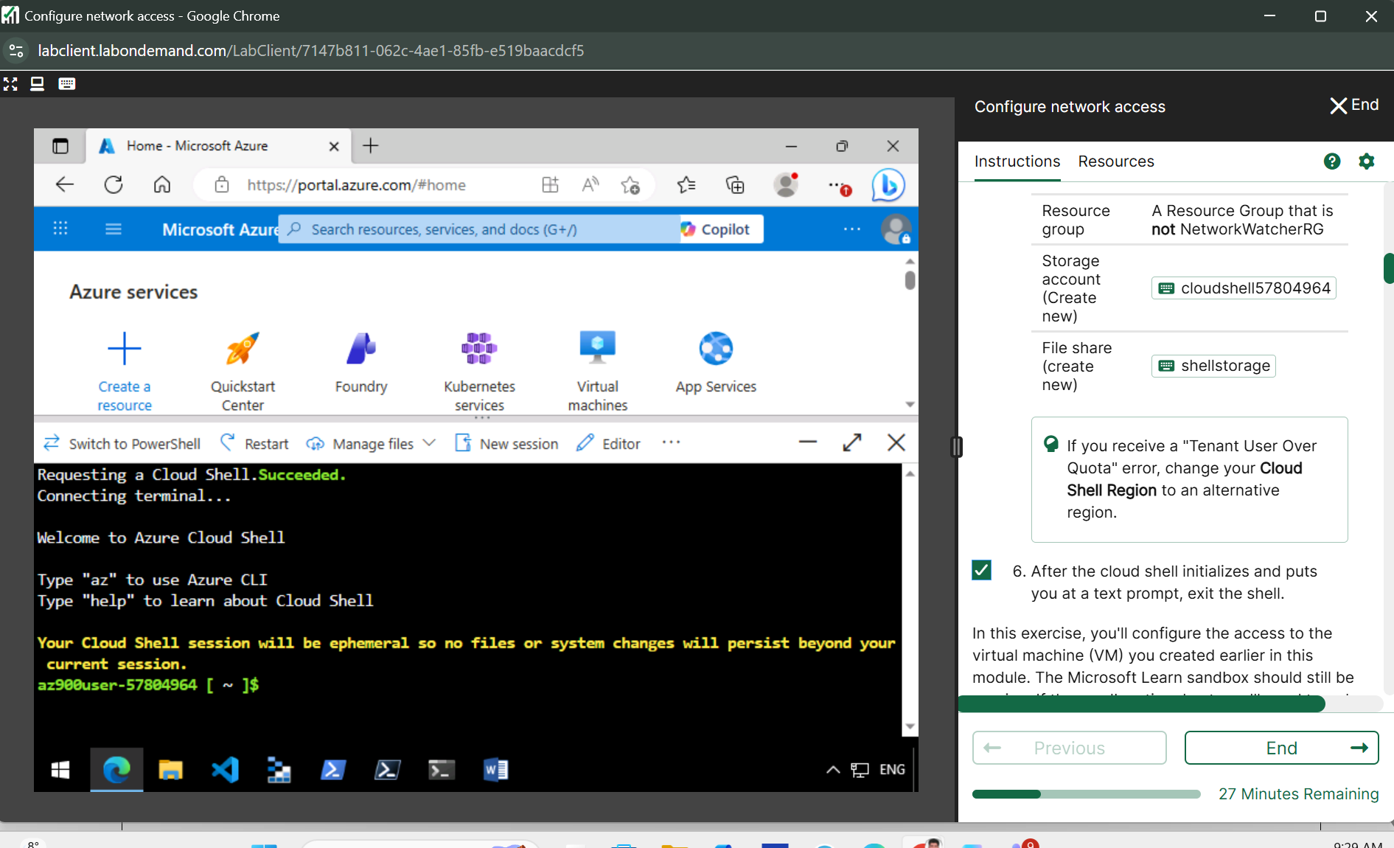

**Task 1: Access web server**

**Run the az vm list-ip-addresses command to get your VM's IP address and store the result as a Bash variable:**

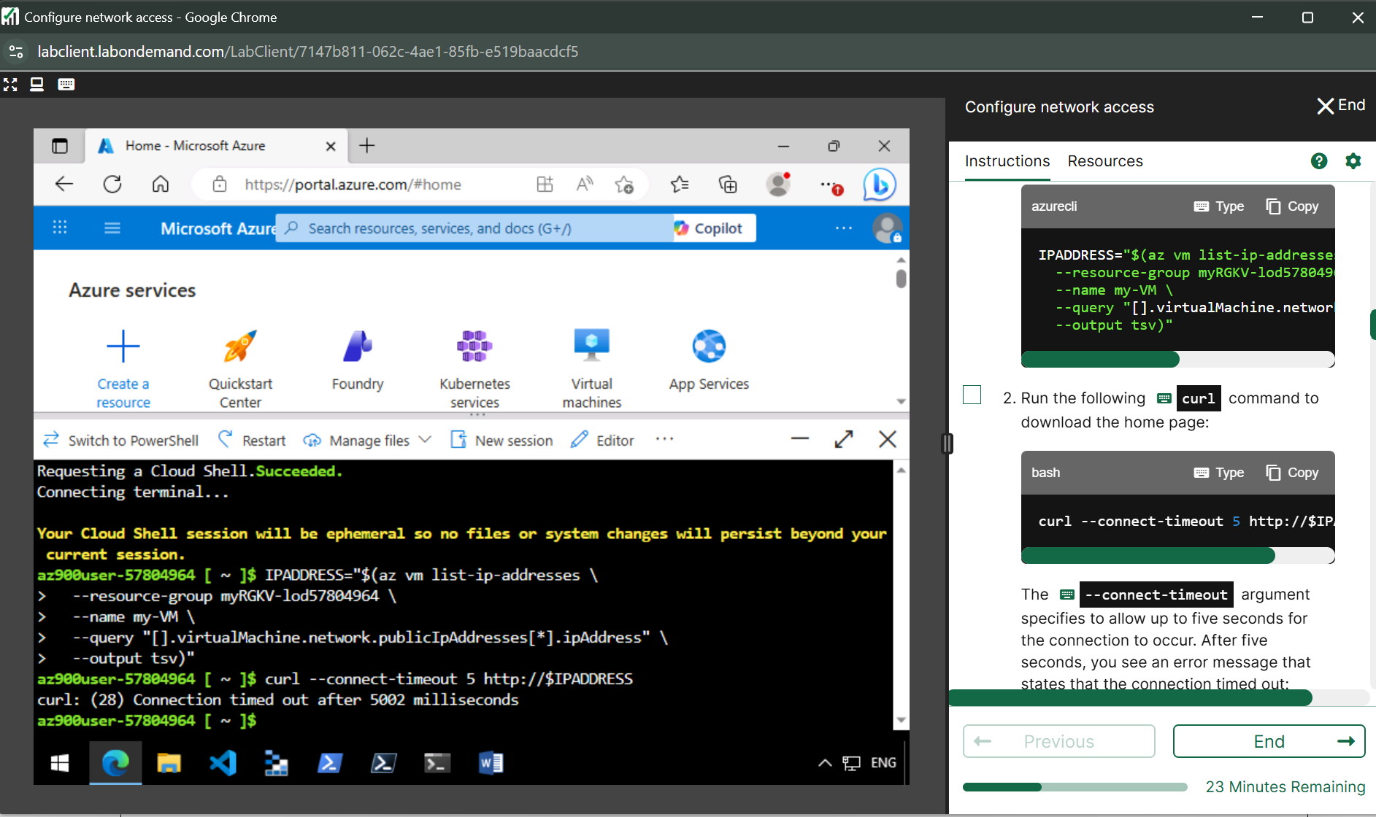

**Curl command**



**Ip address**

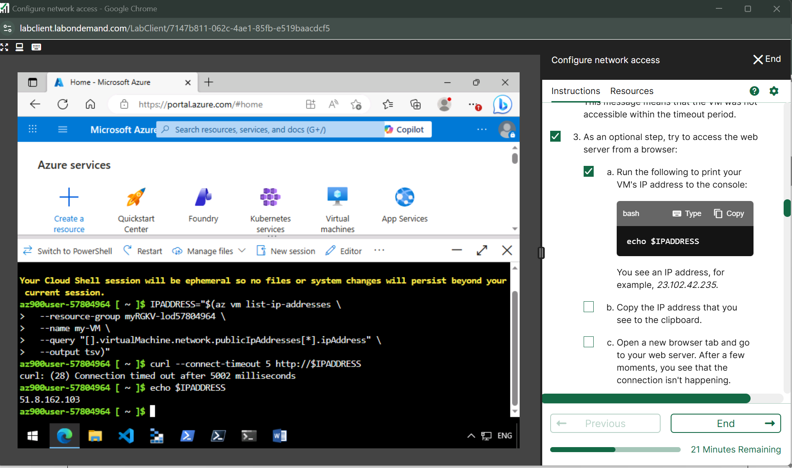

After few wait browser timeout and see something like this

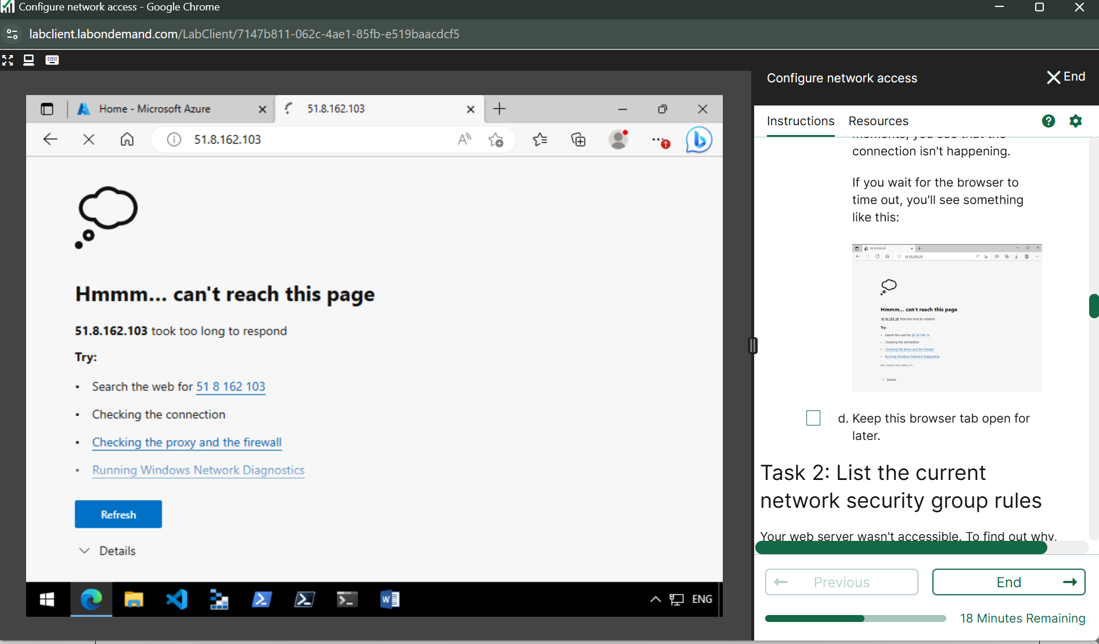

**Task 2:**

**List the current network security group rules**

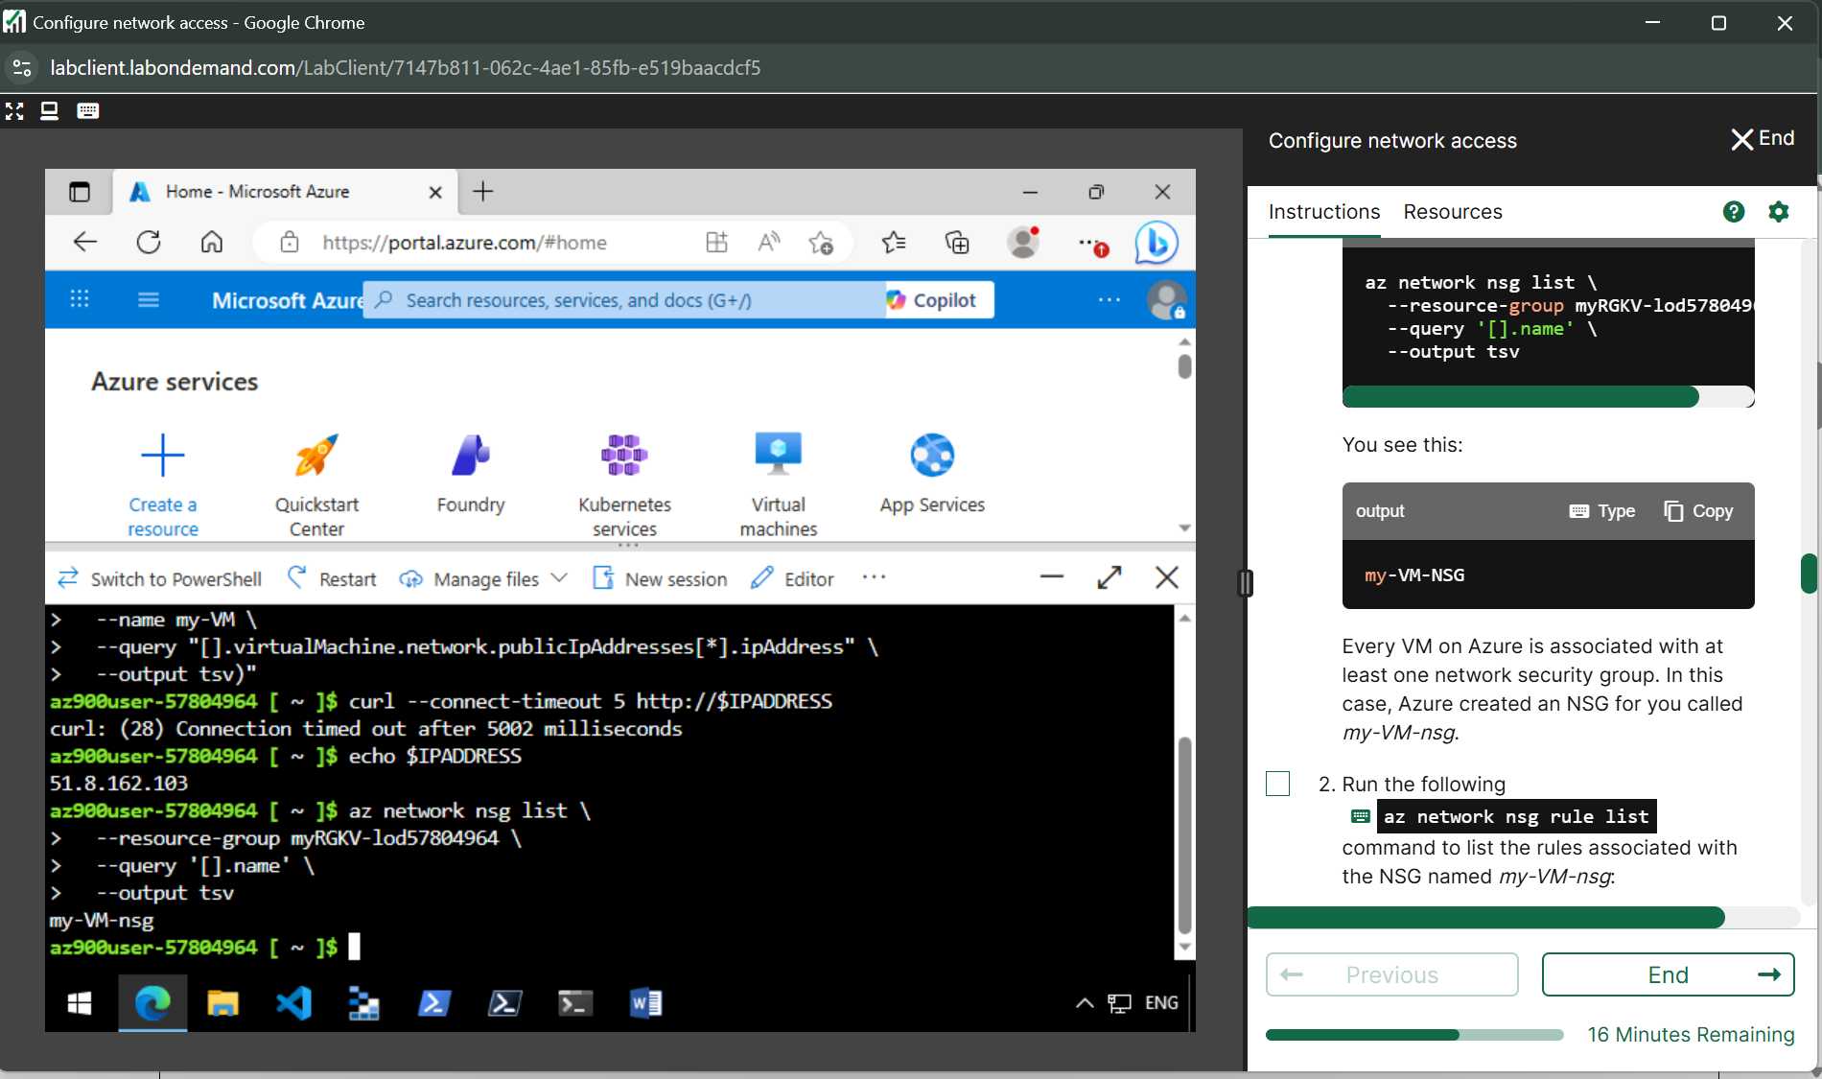

**Run the  az network nsg rule list command to list the rules associated with the NSG named *my-VM-nsg*:**

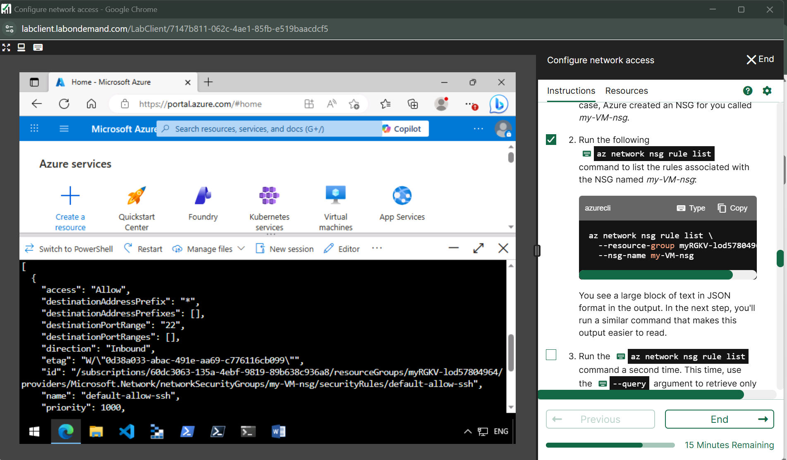

**Run the az network nsg rule list command a second time. This time, use the --query argument to retrieve only the name, priority, affected ports, and access (Allow or Deny) for each rule. The --output argument formats the output as a table so that t's easy to read.**

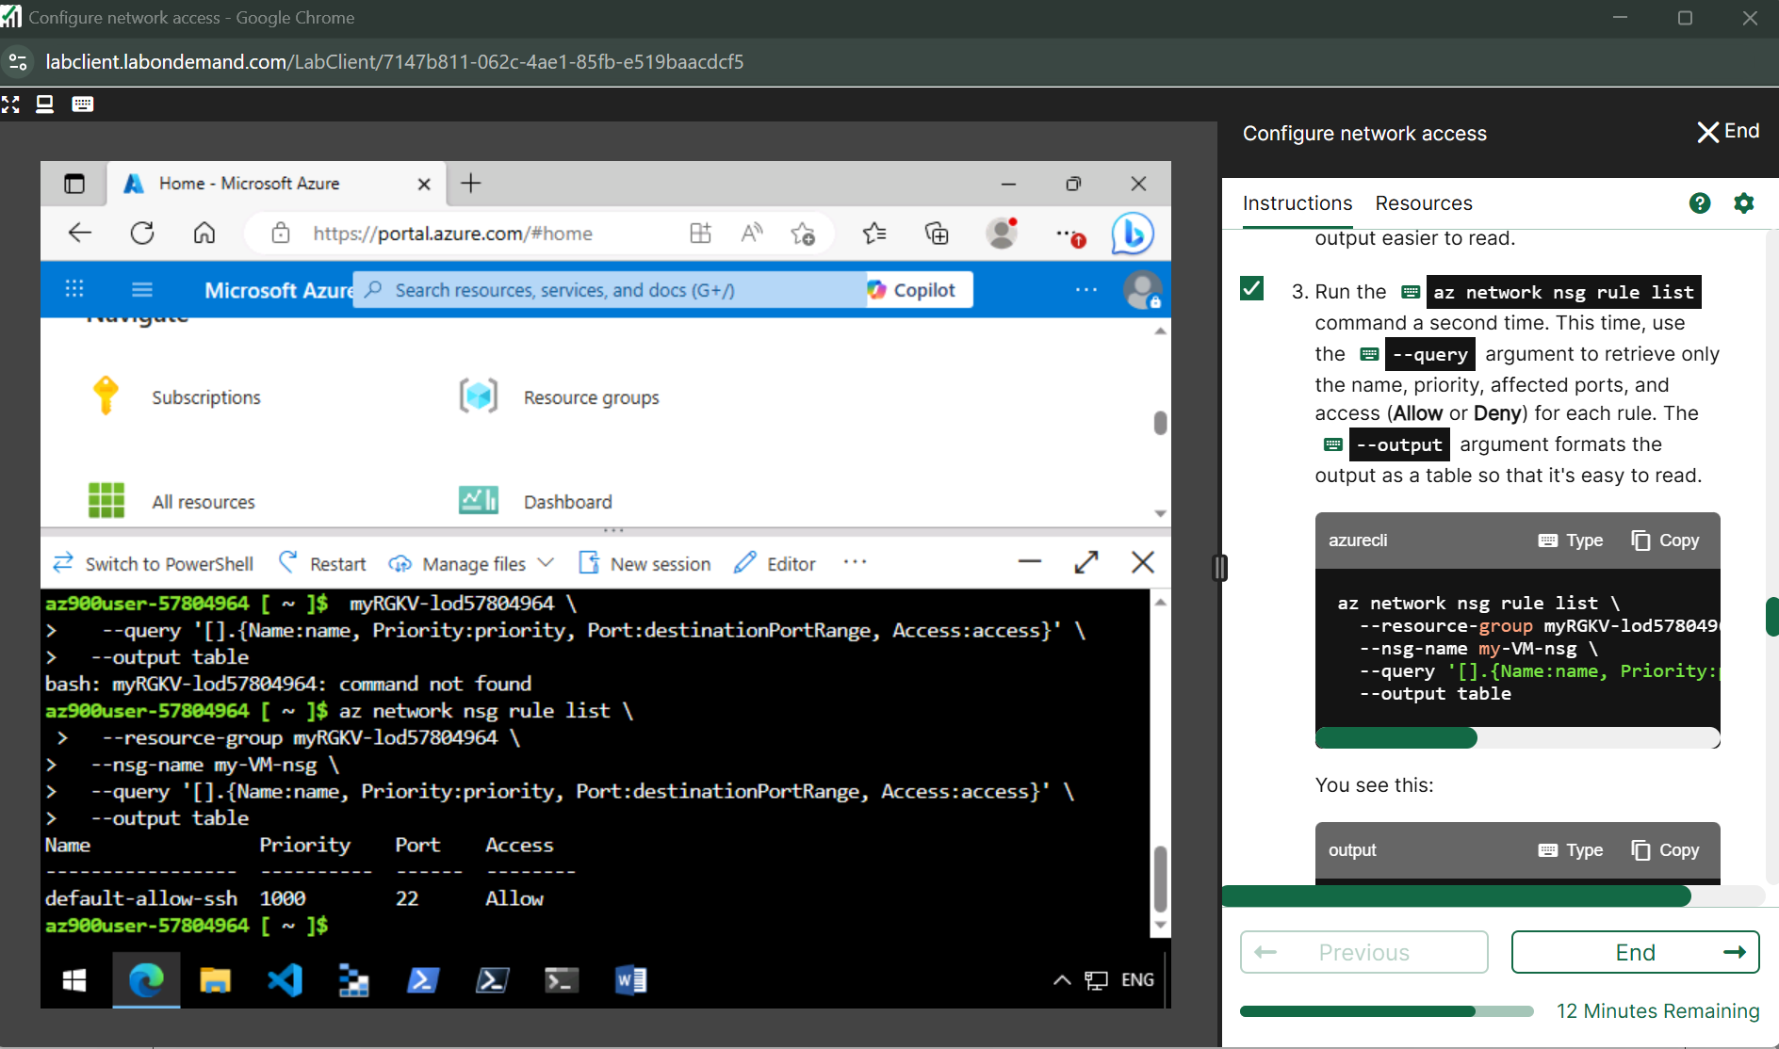

**Task 3: Create the network security rule**

**Run the  az network nsg rule create command to create a rule called *allow-http* that allows inbound access on port 80**

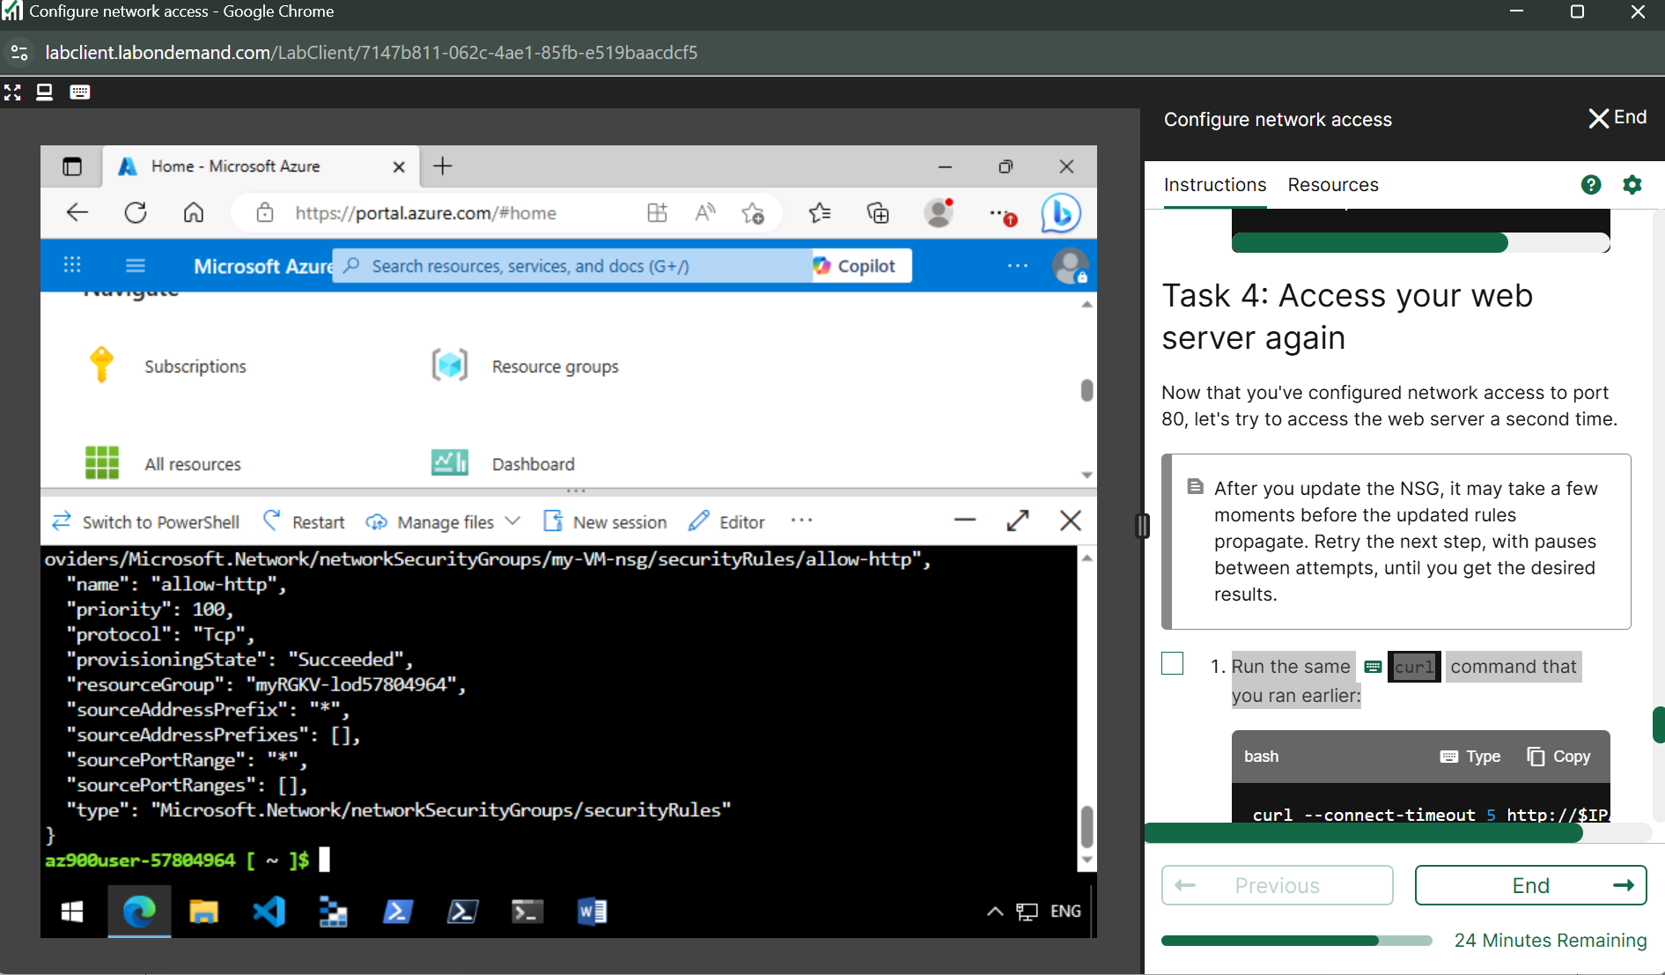

**To verify the configuration, run az network nsg rule list to see the updated list of rules**

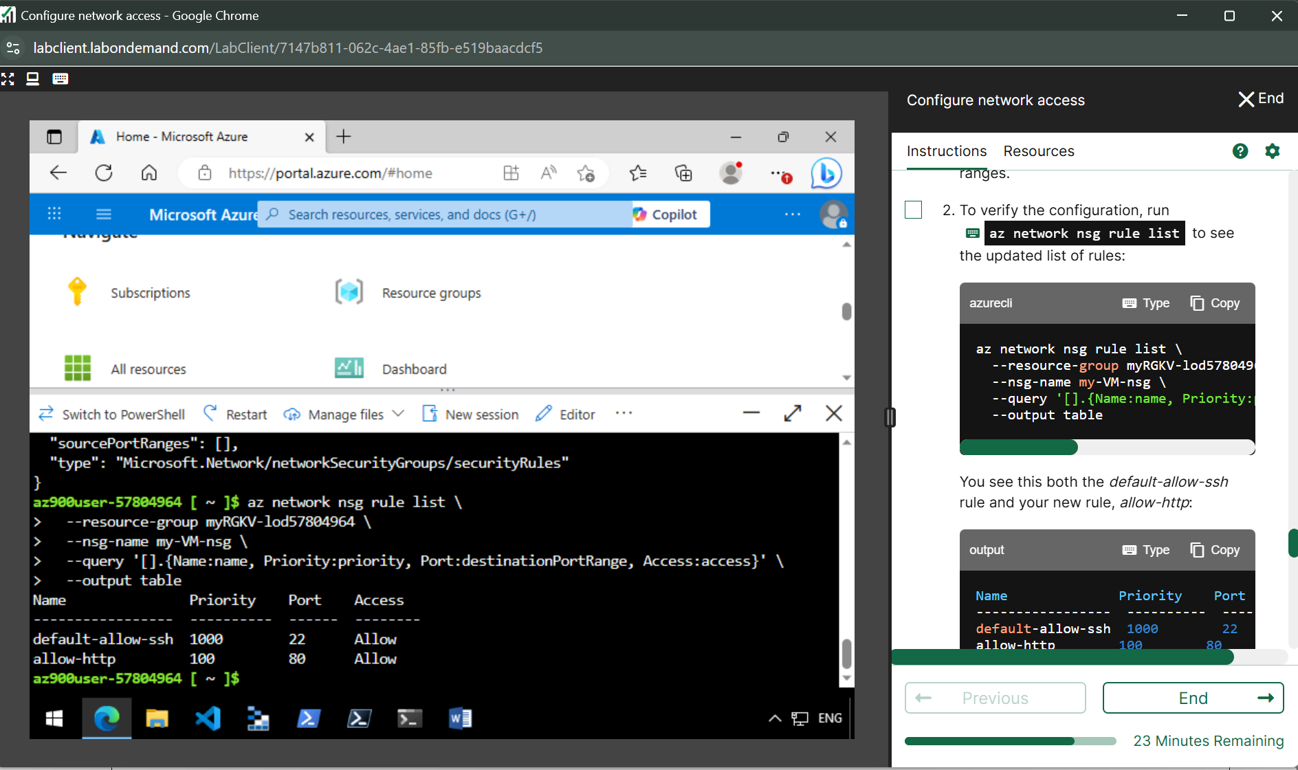

**Task 4: Access web server again  
Run the same curl command that ran earlier:**

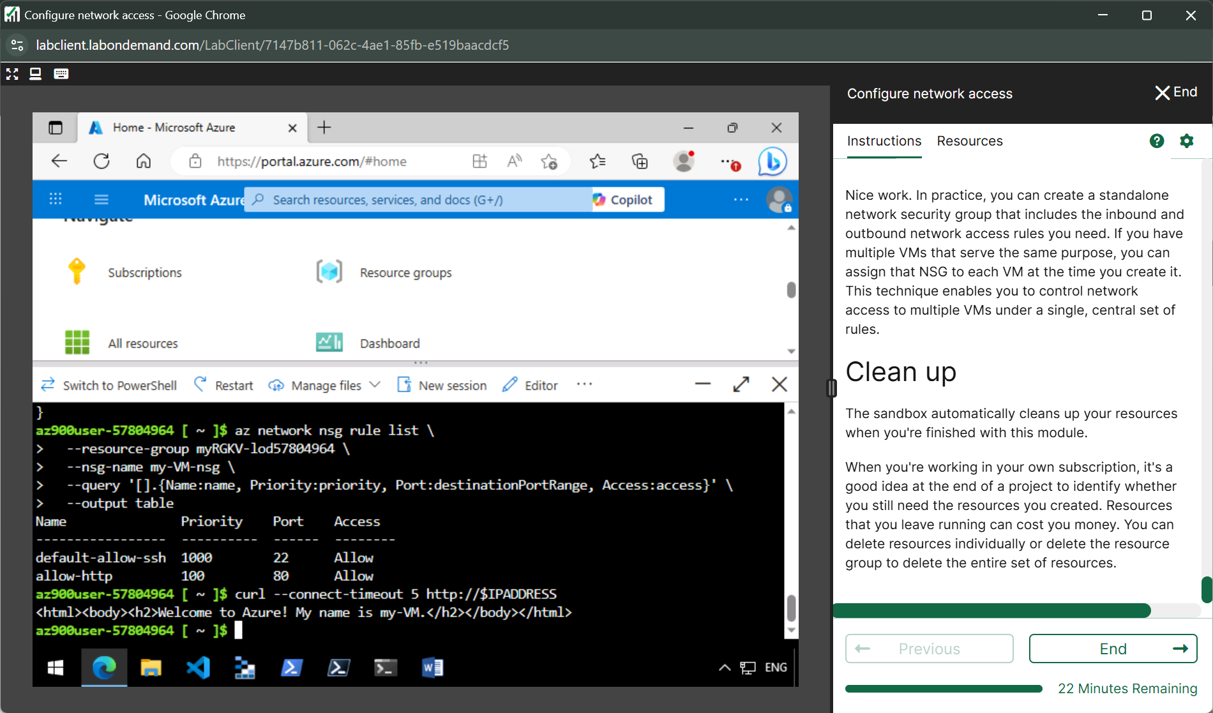

**Lab 4** [**Create a storage blob**](https://msle.learnondemand.net/Lab/54711?instructionSetLang=en&classId=712625)

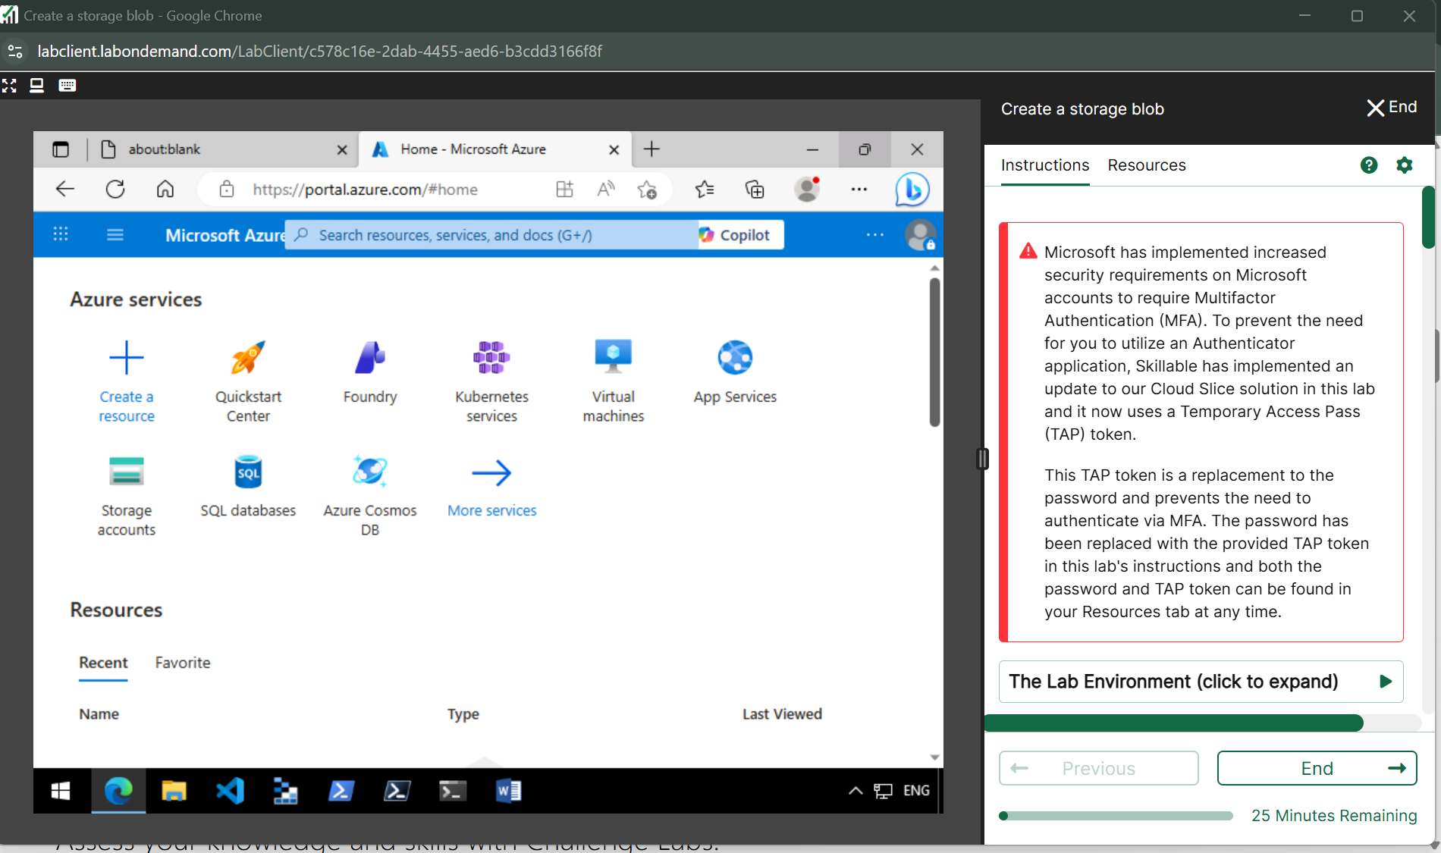

**Create storage blob**

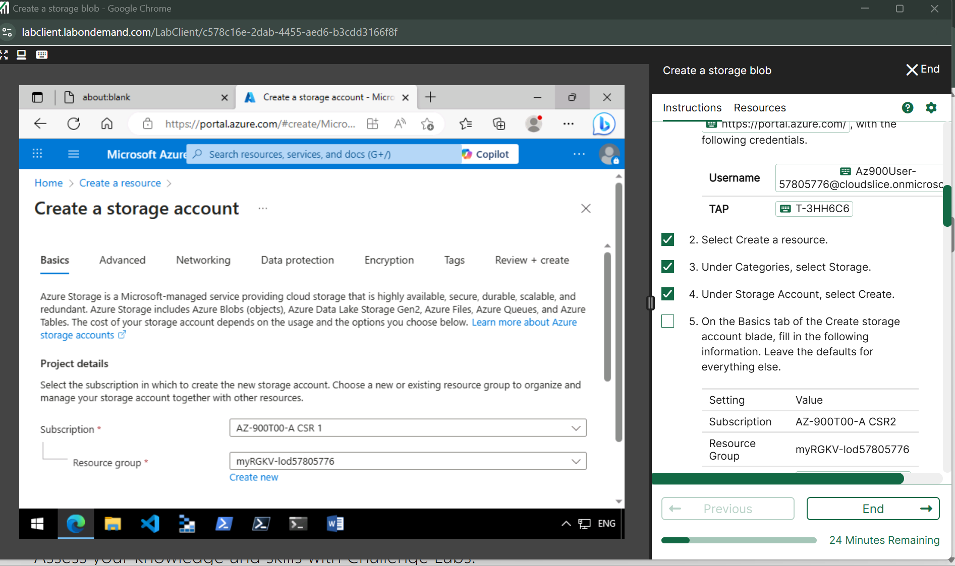

**Instance settings**

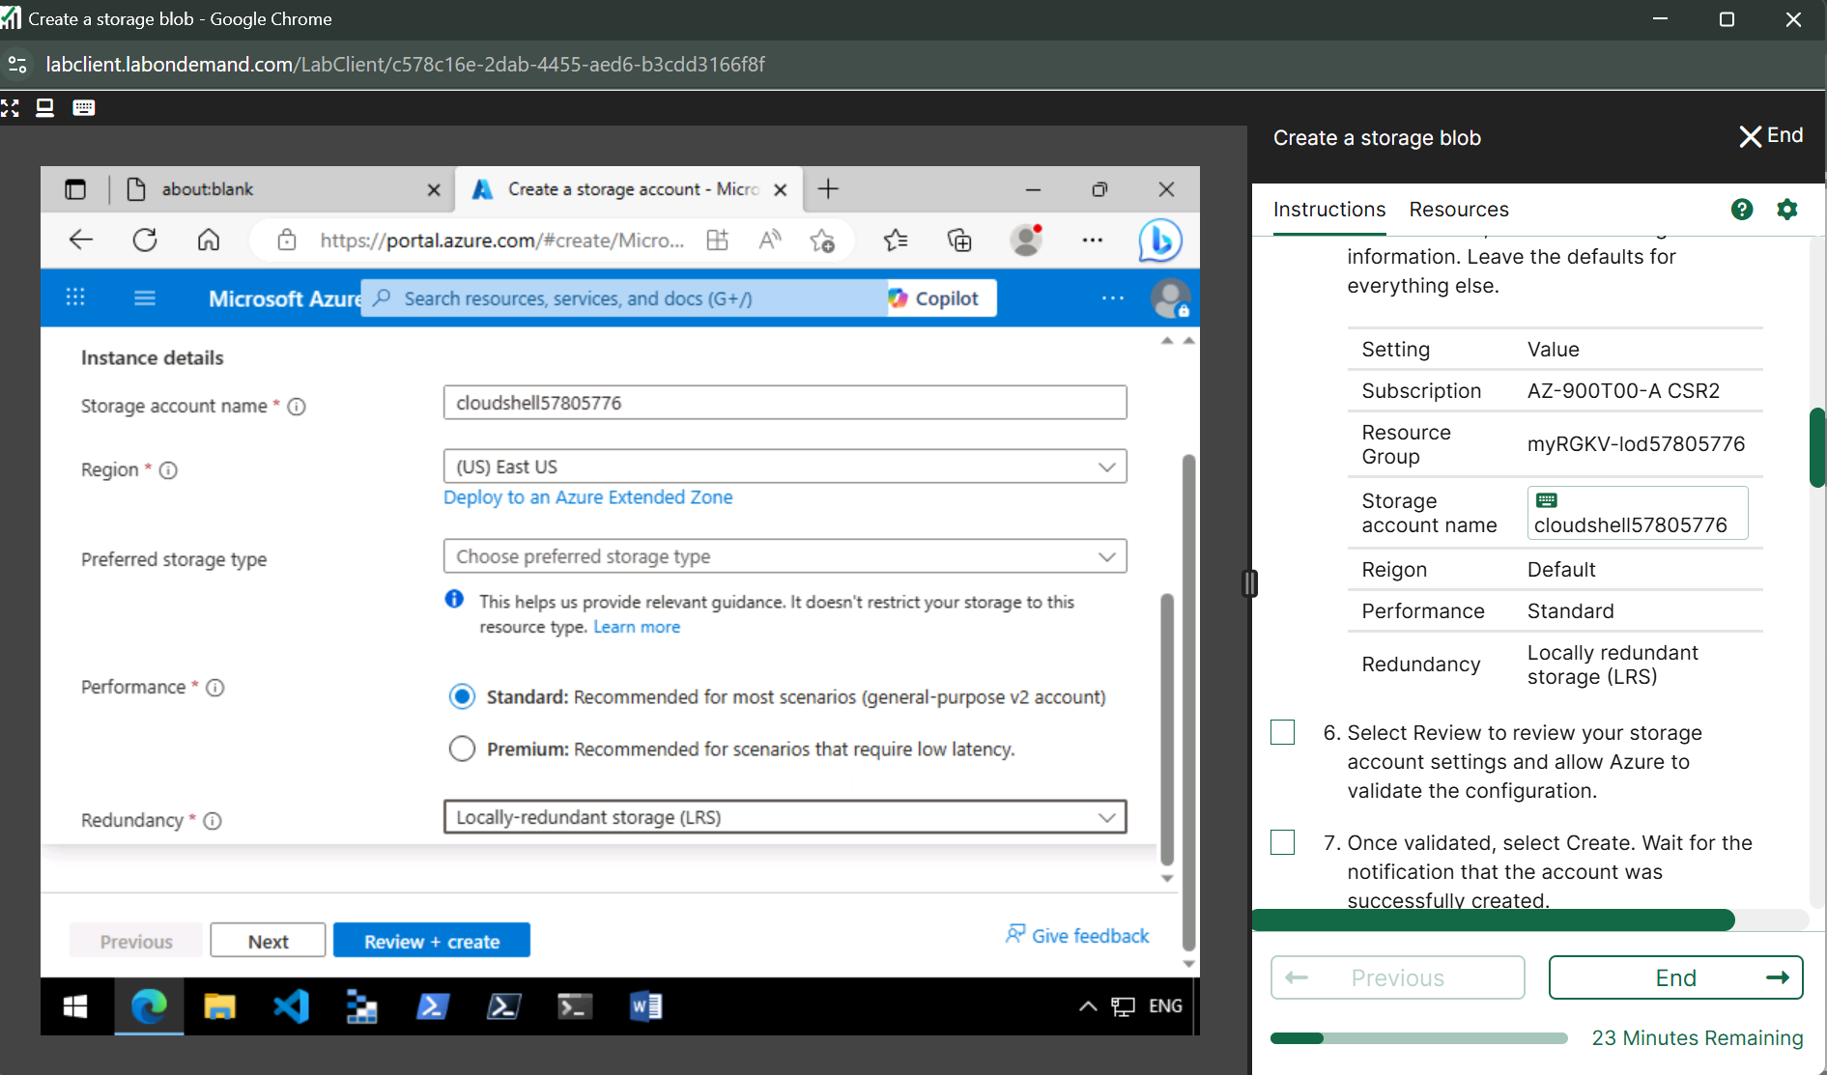

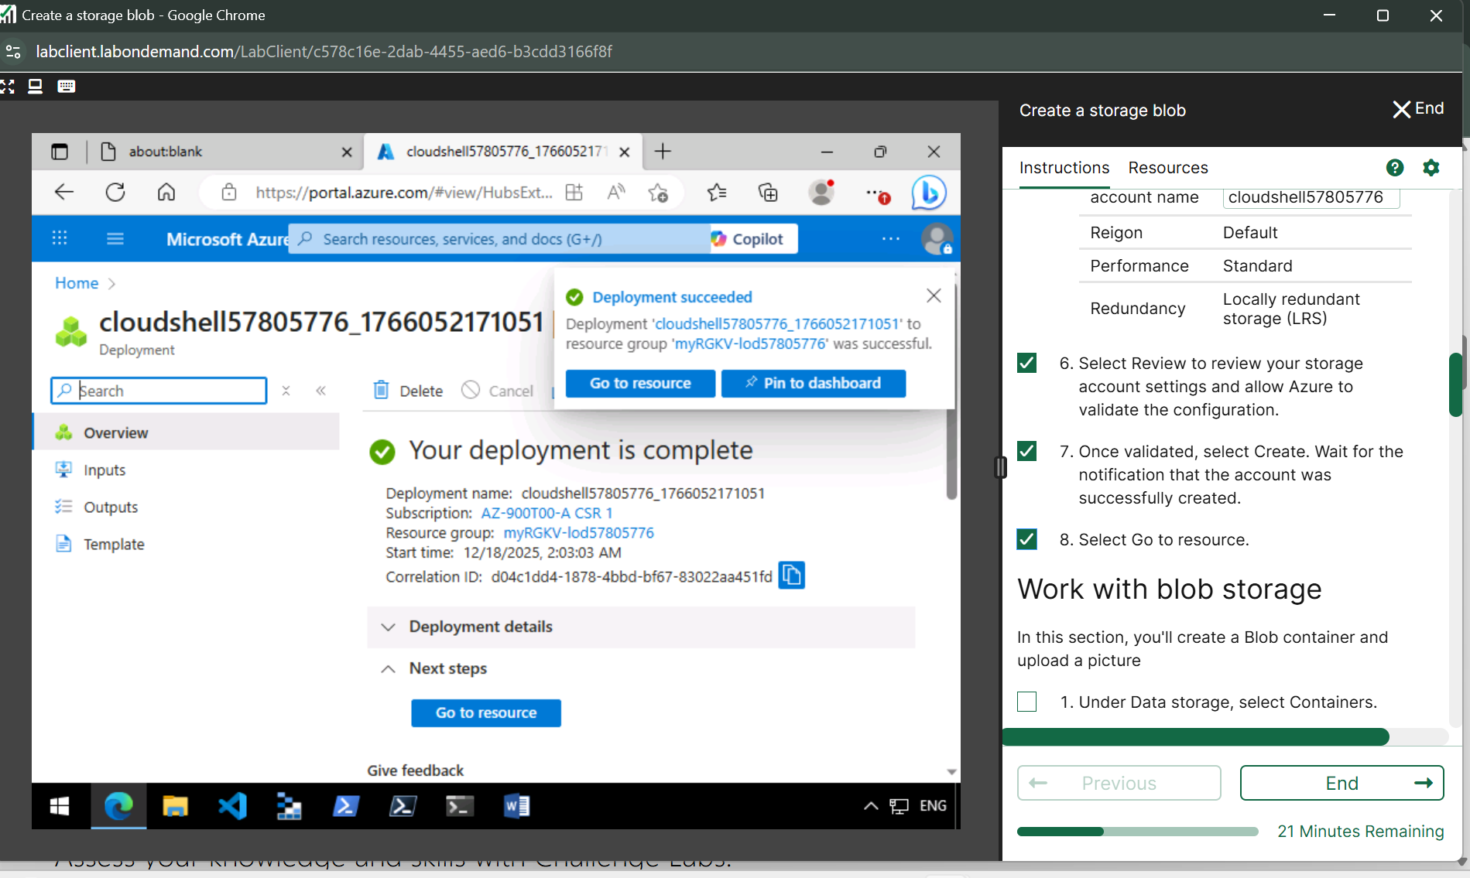

**Check resources**

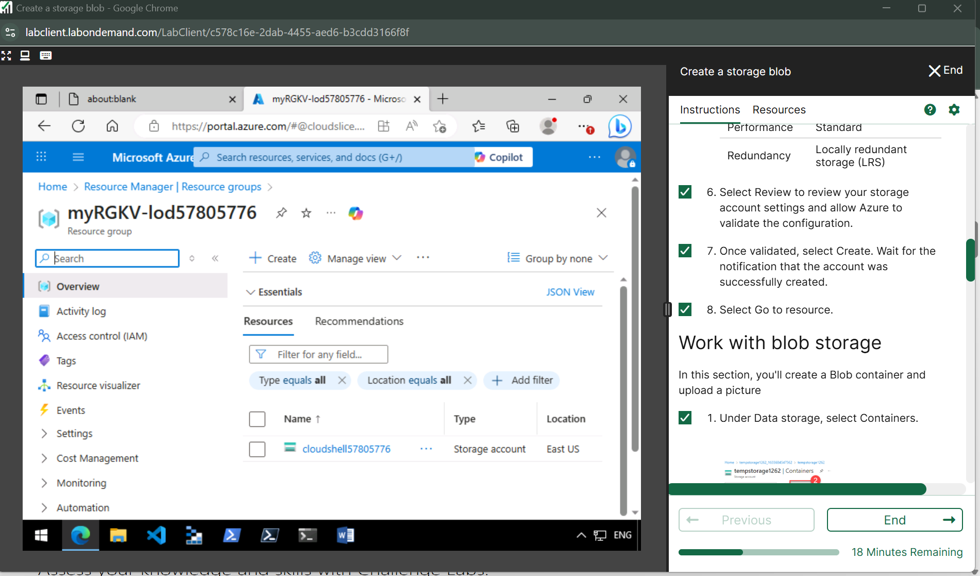

**Work with blob storage**

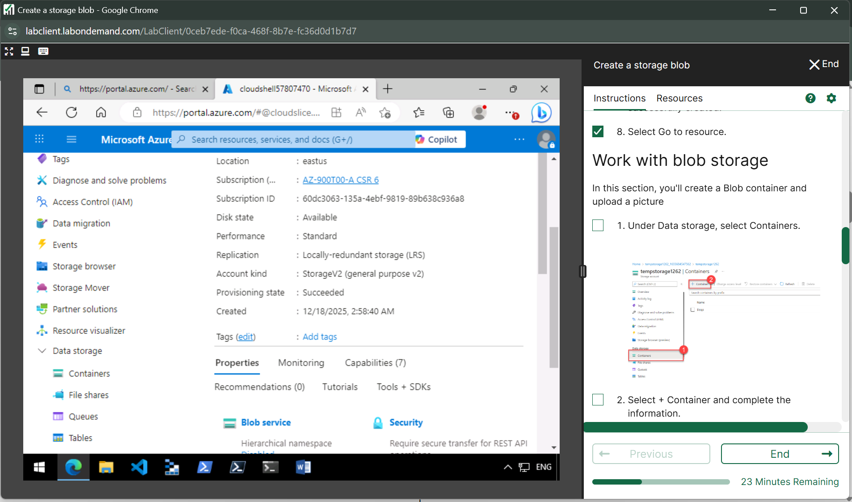

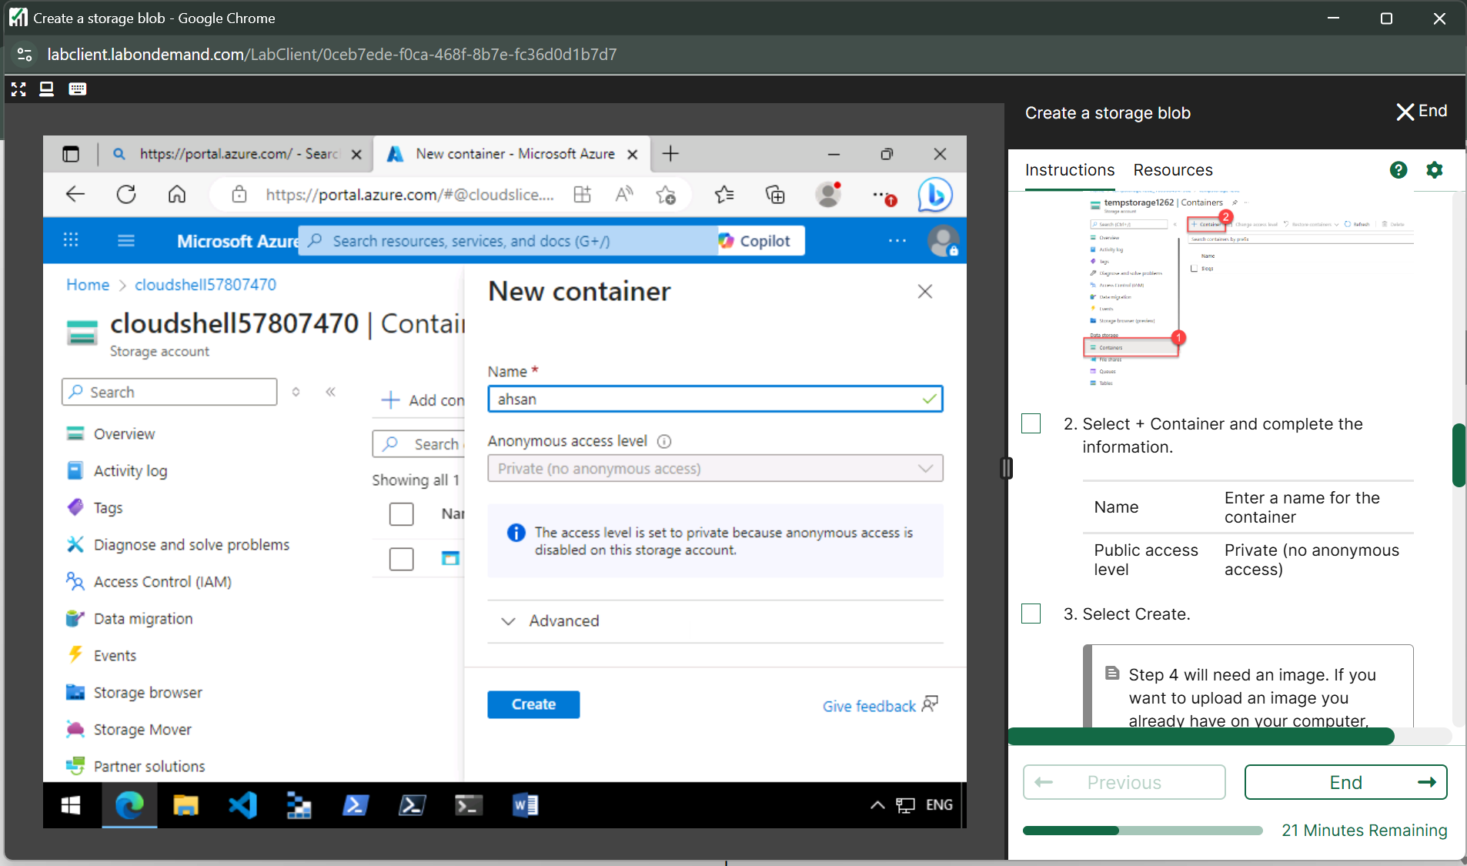

**Upload the file**

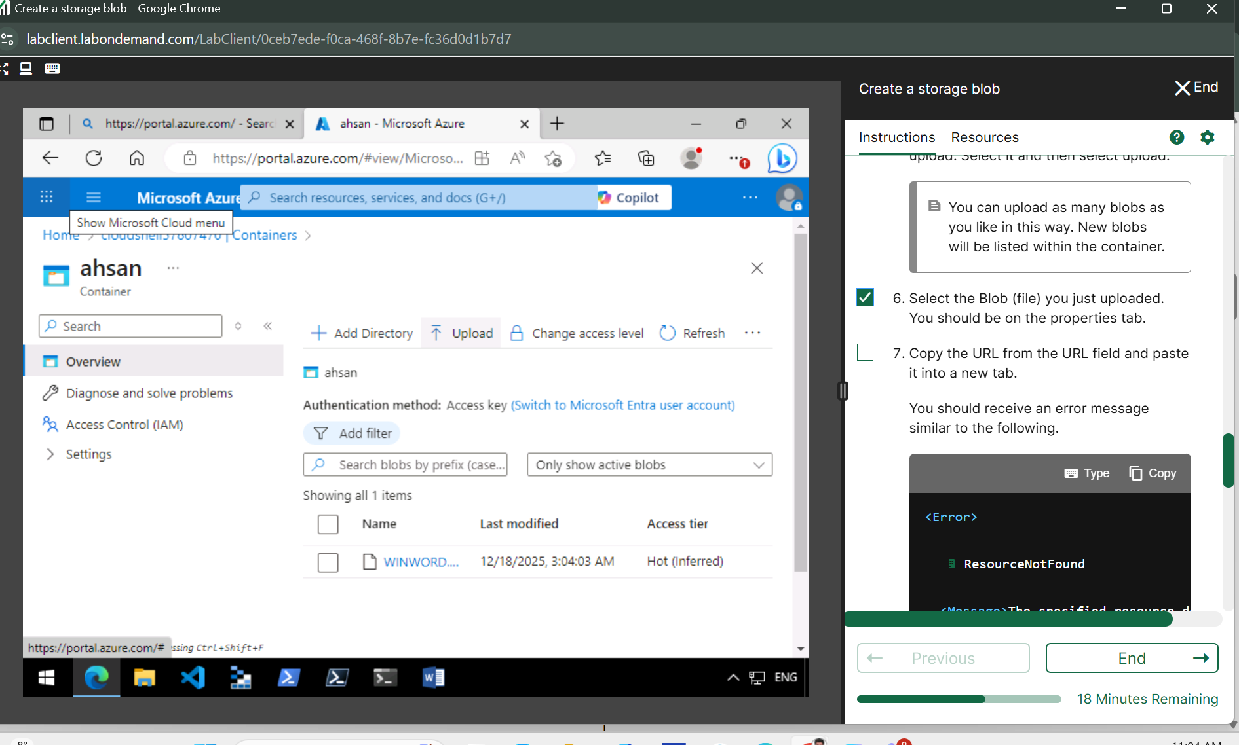

**Open url in next tab**

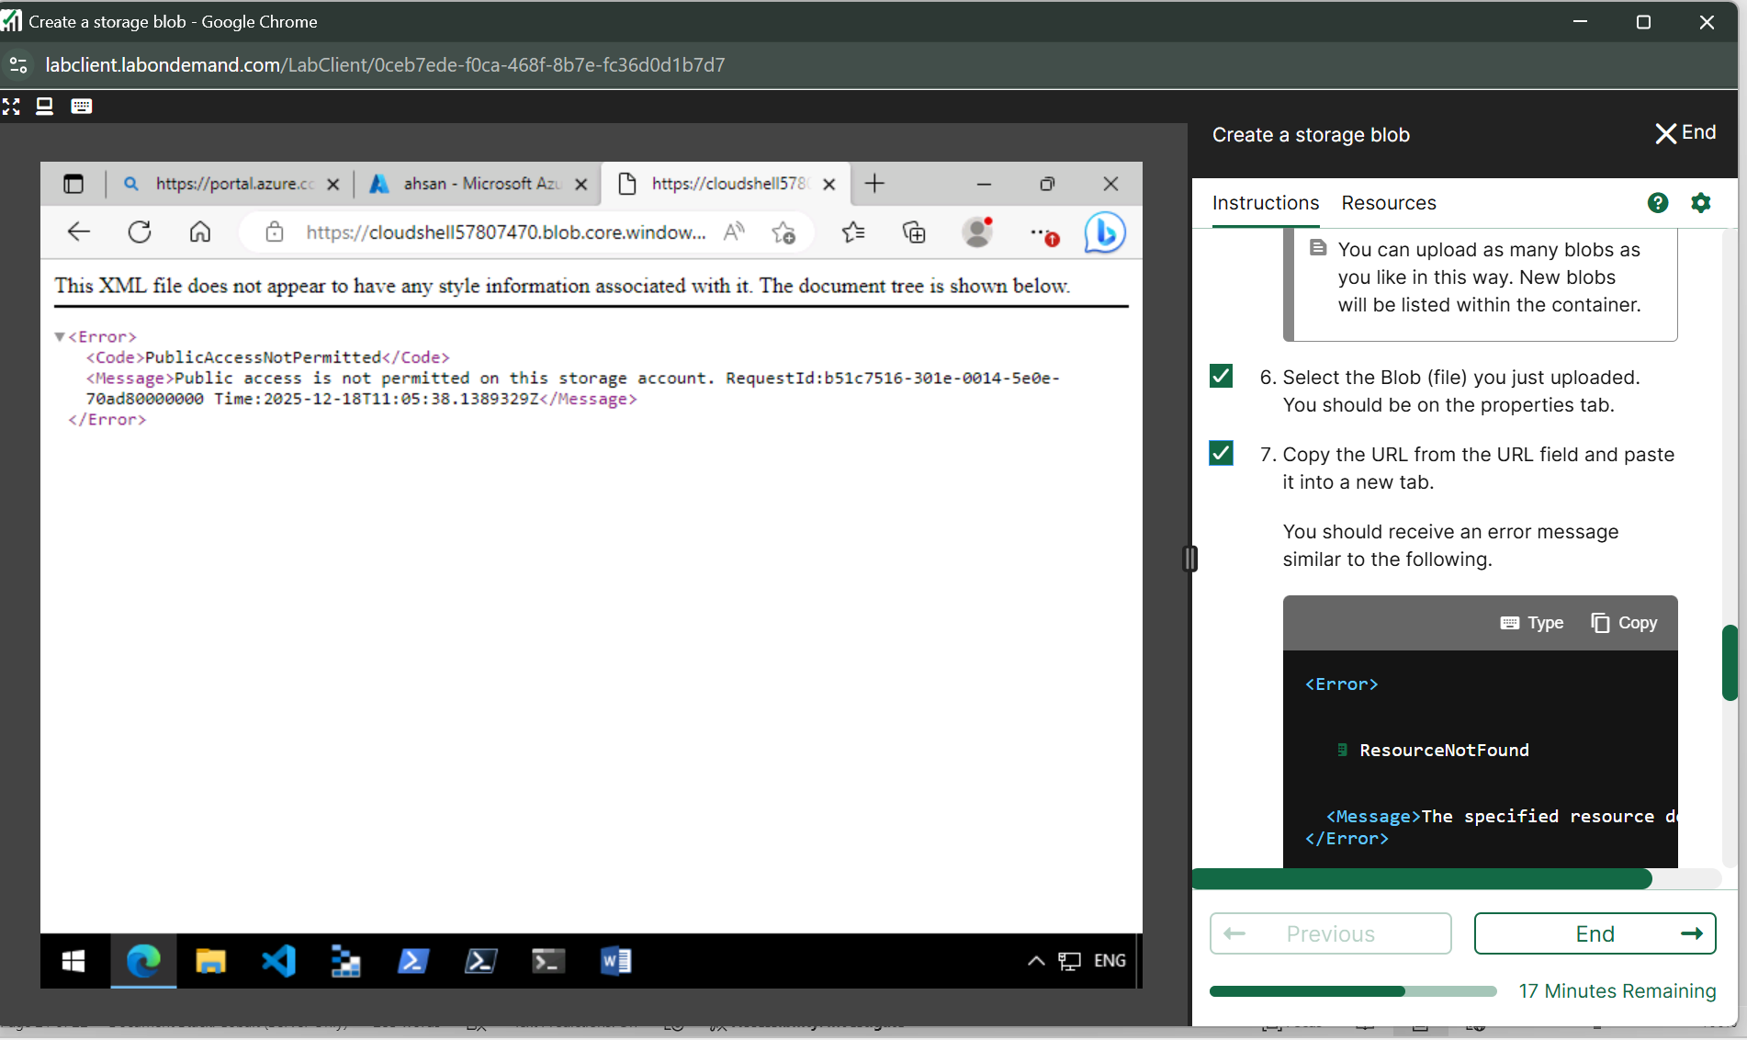

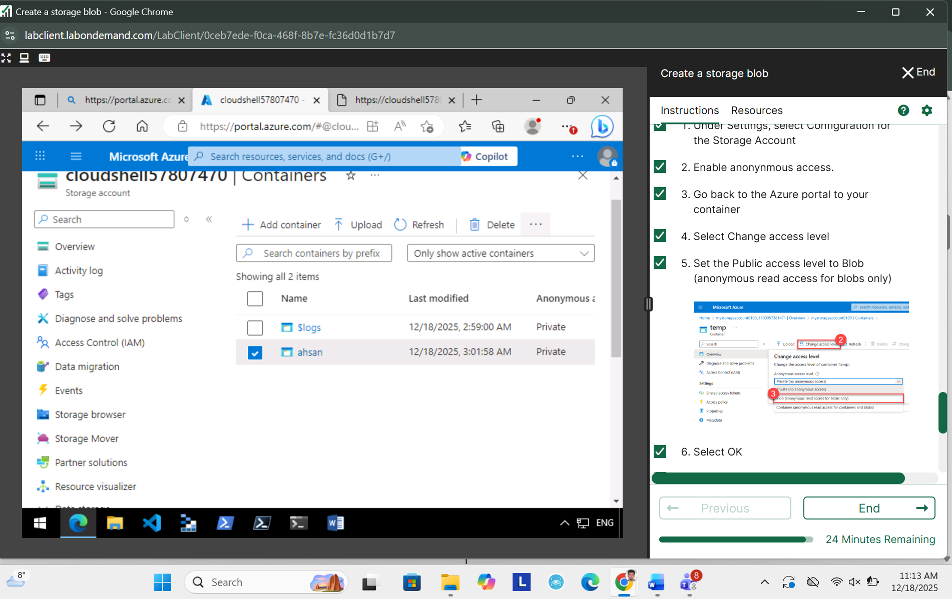

**Lab 5** [**Configure a resource lock**](https://msle.learnondemand.net/Lab/54713?instructionSetLang=en&classId=712625)

**Azure**

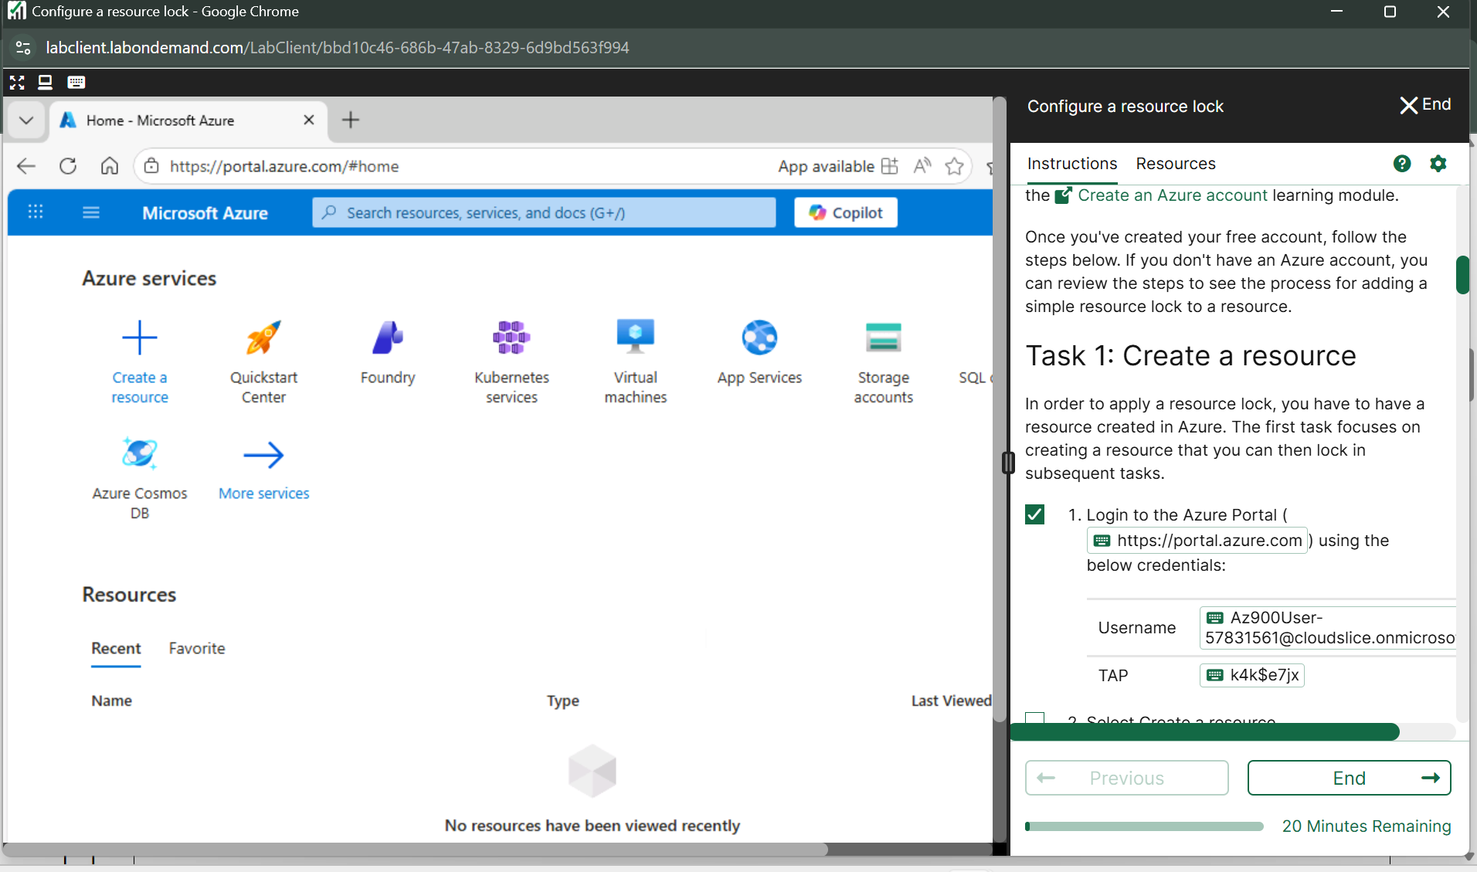

**Create Storage account**

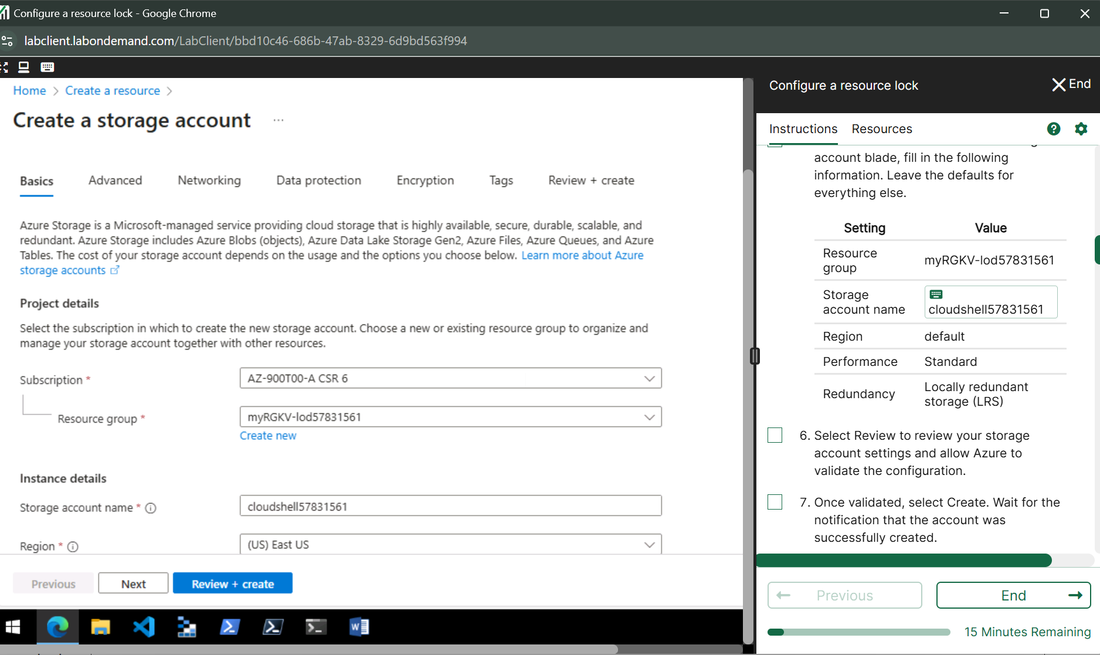

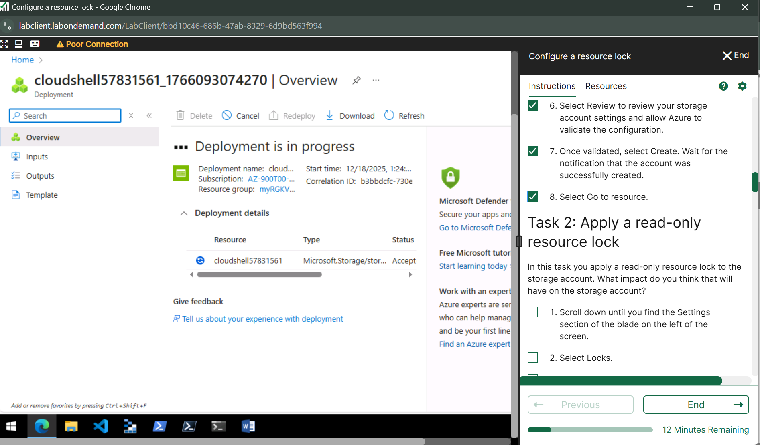

**Task 2: Apply a read-only resource lock**

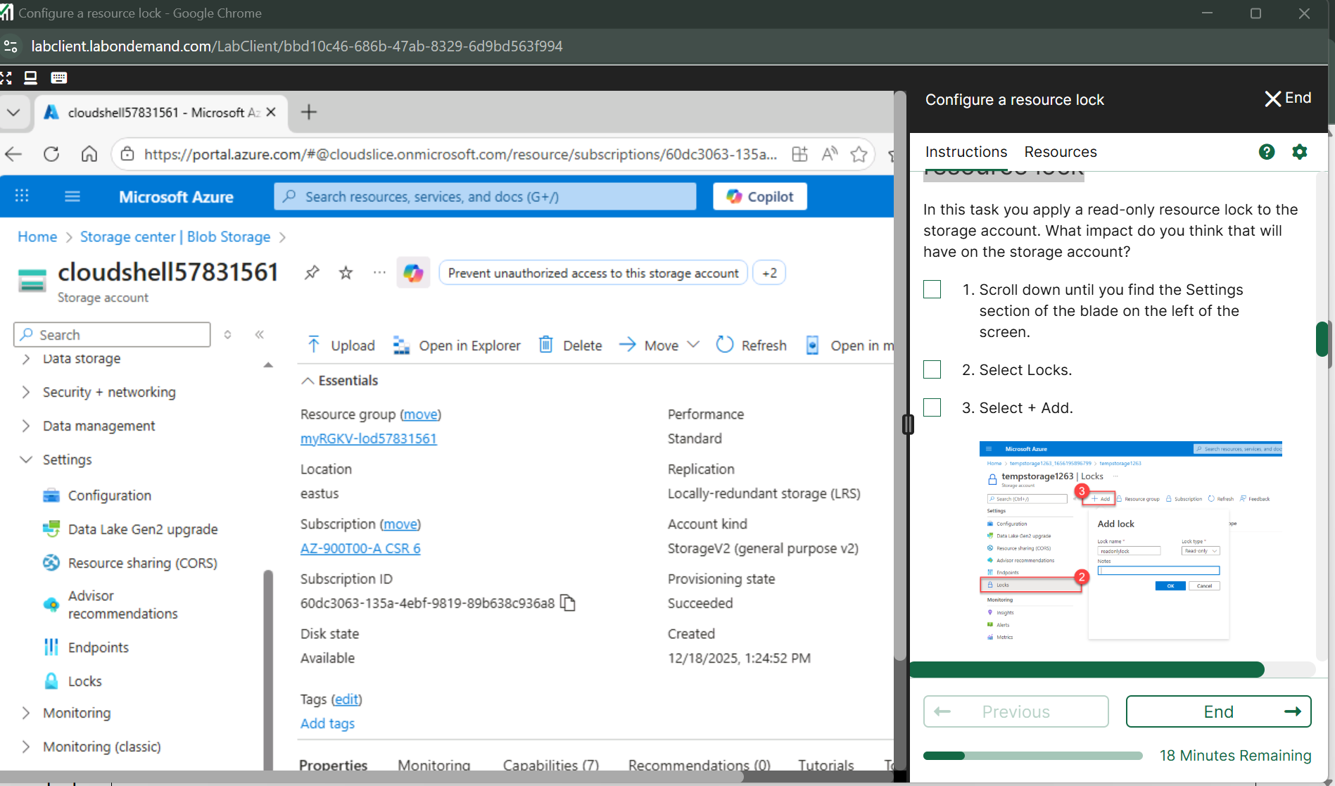

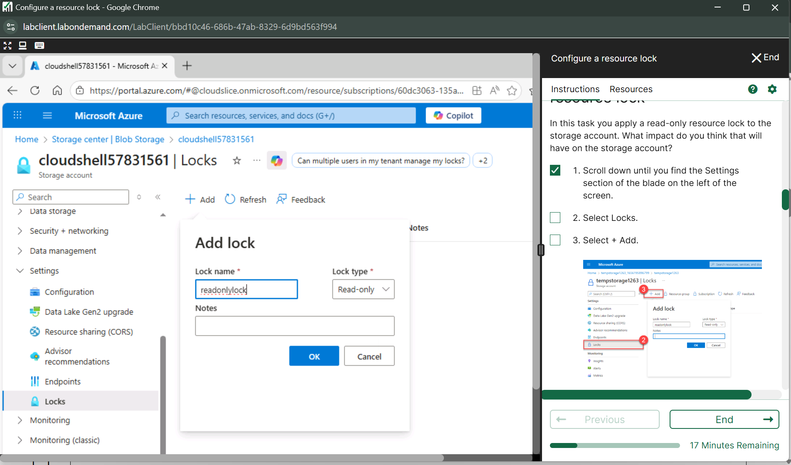

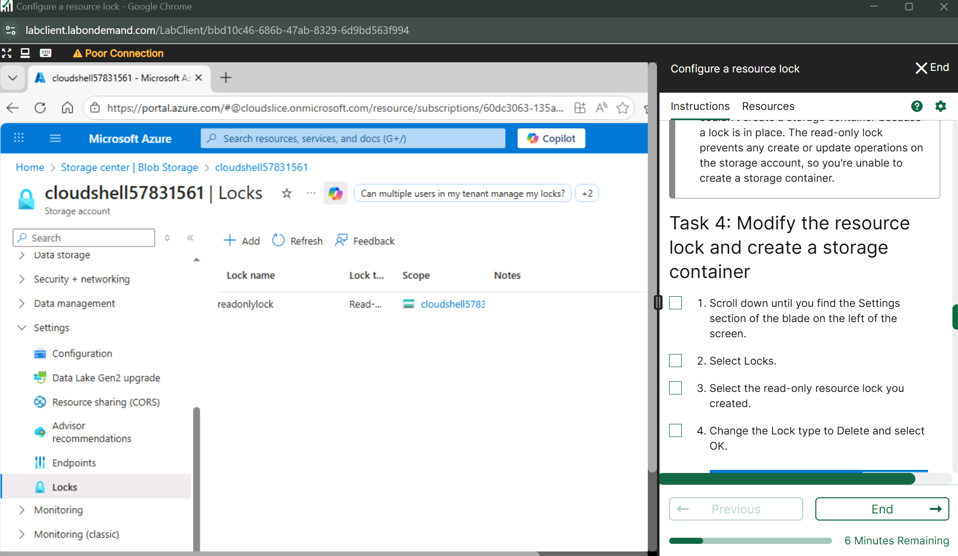

**Delete the lock**

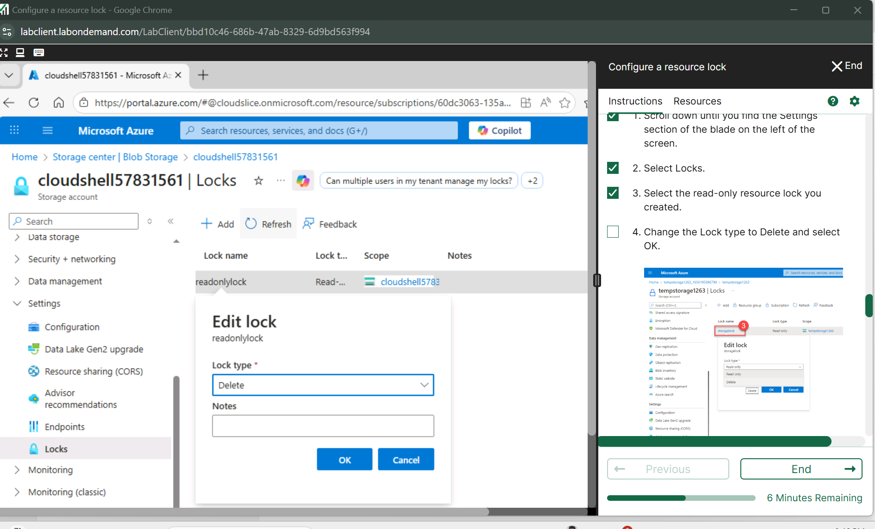

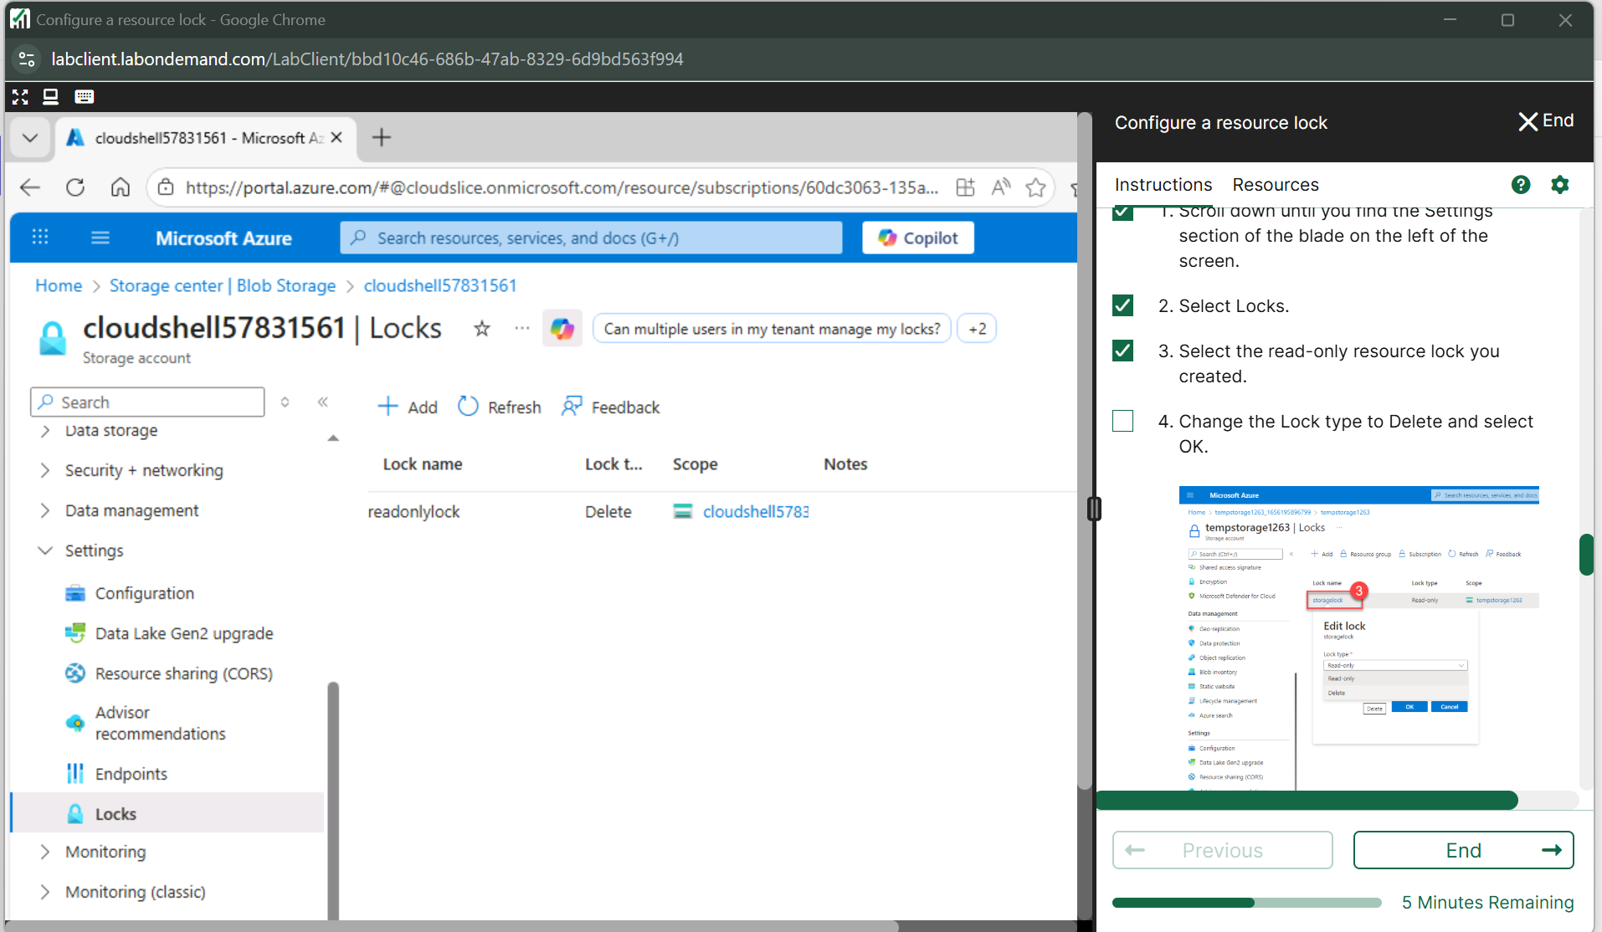

**Add a container to the storage account**

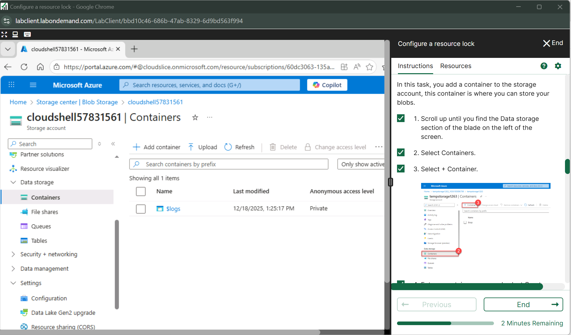

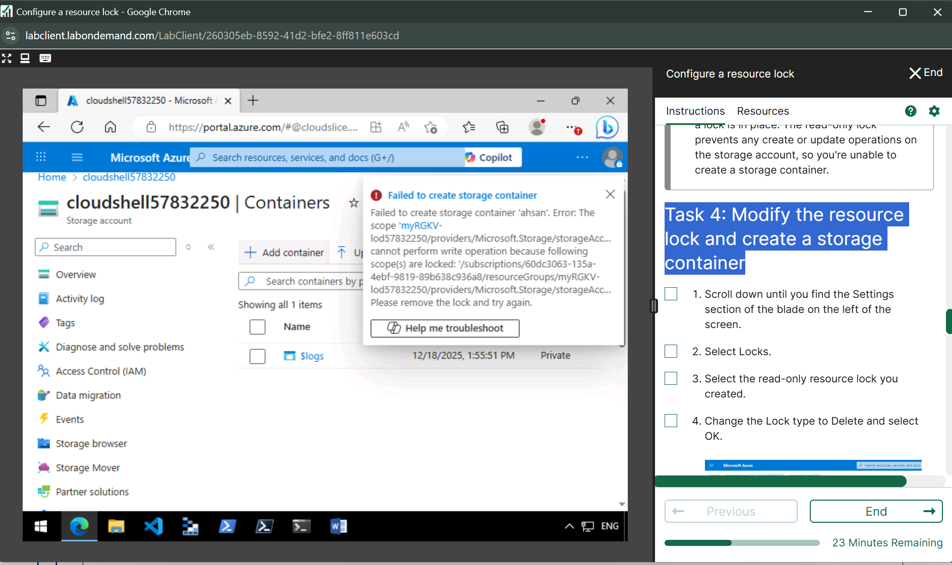

**Modify the resource lock and create a storage container**

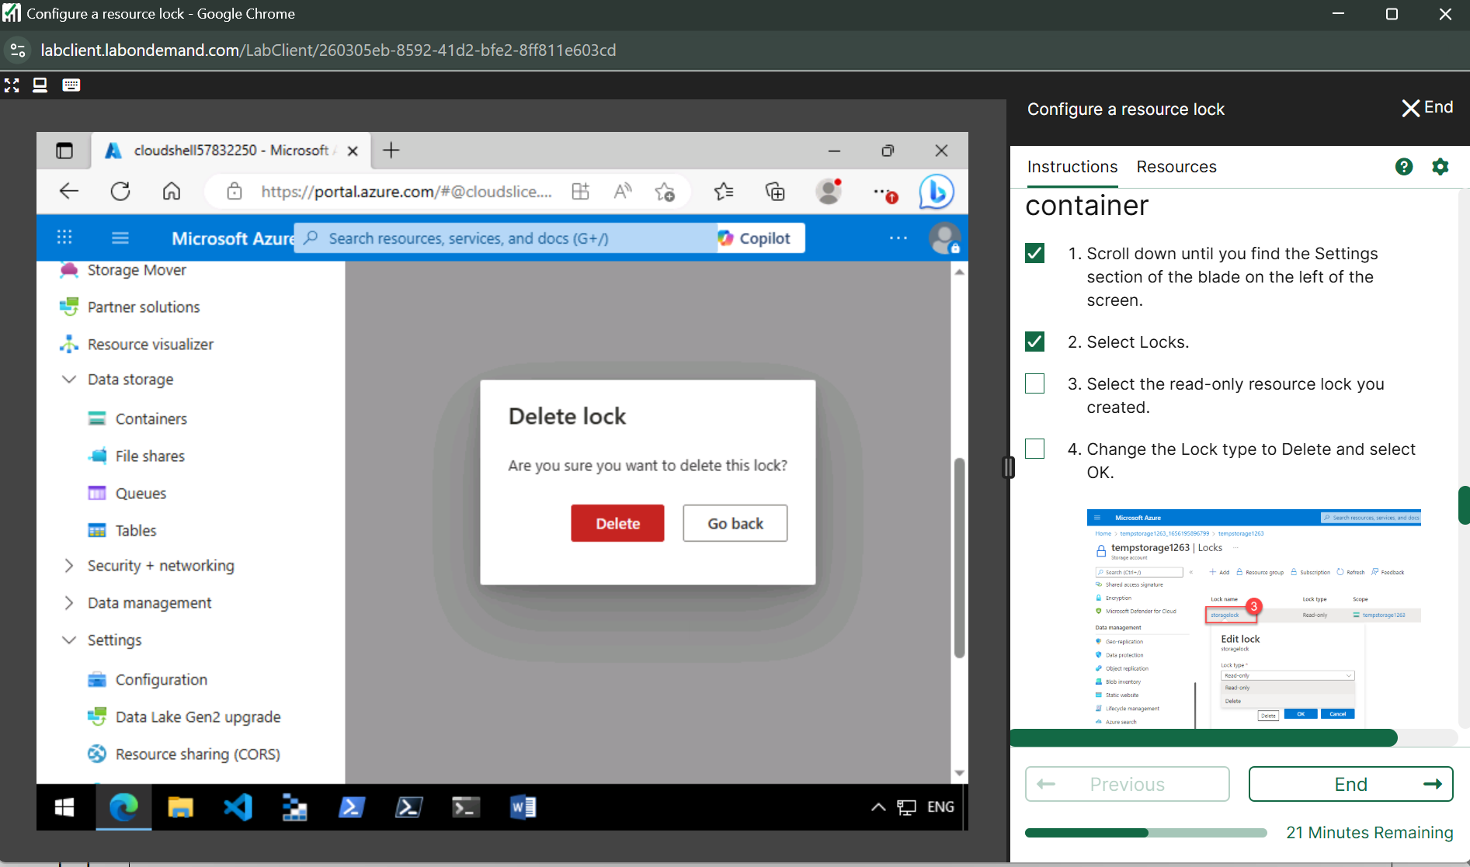

**Add container to the storage account**

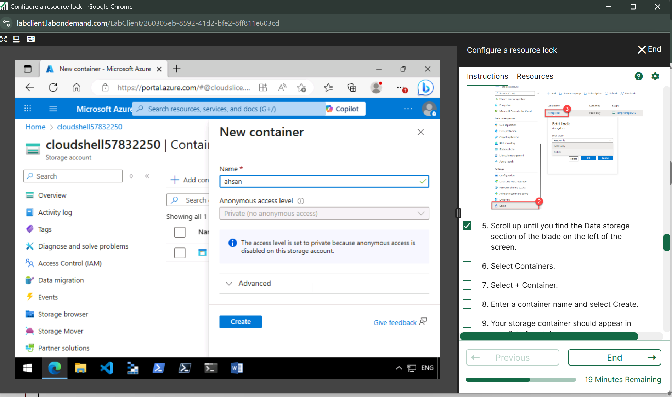

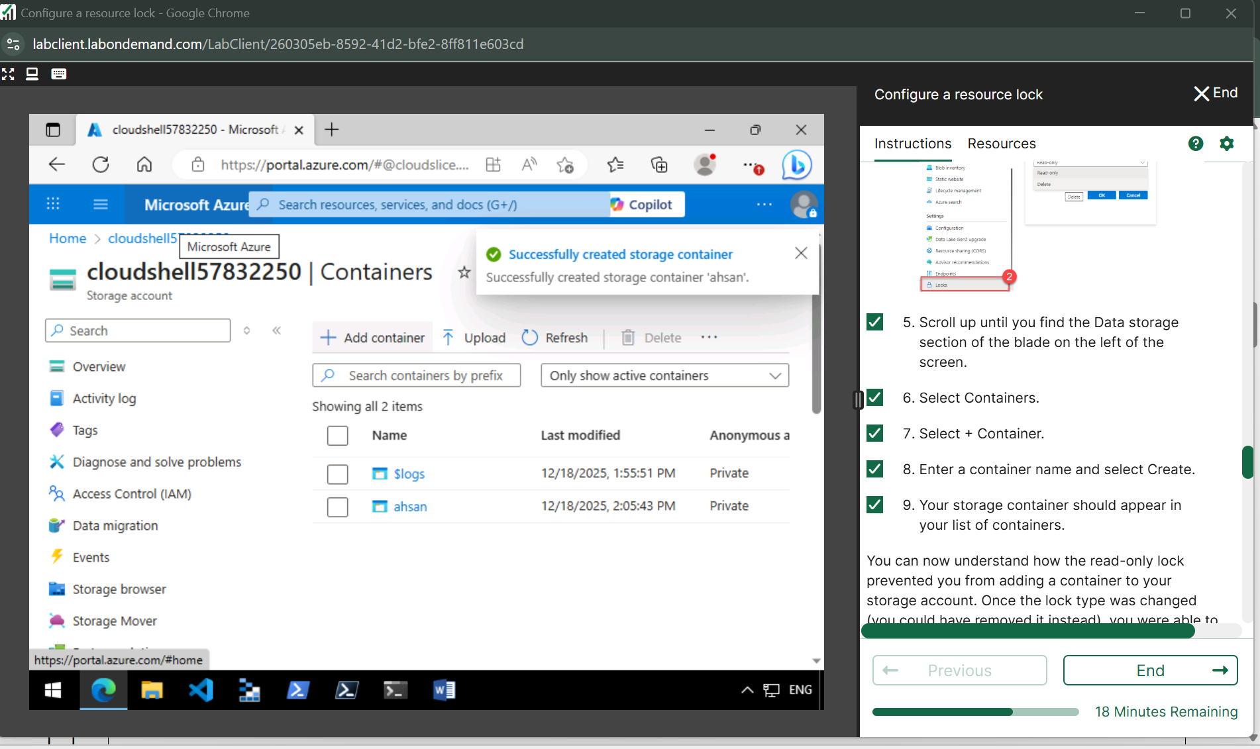

**Task 5: Delete the storage account**

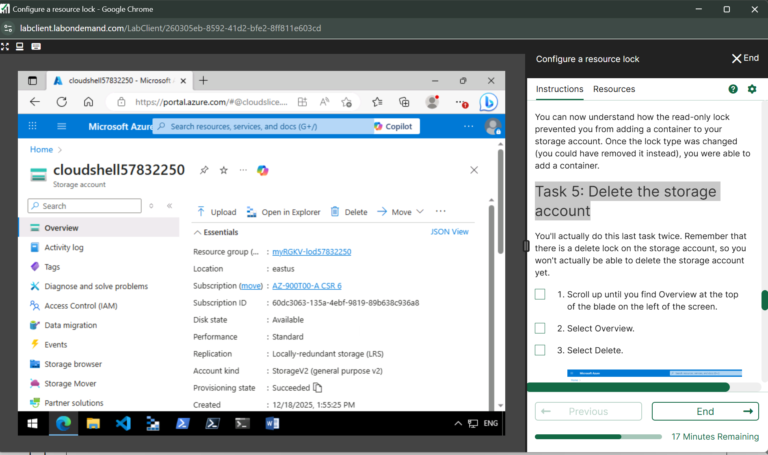

**Delete the storage account**

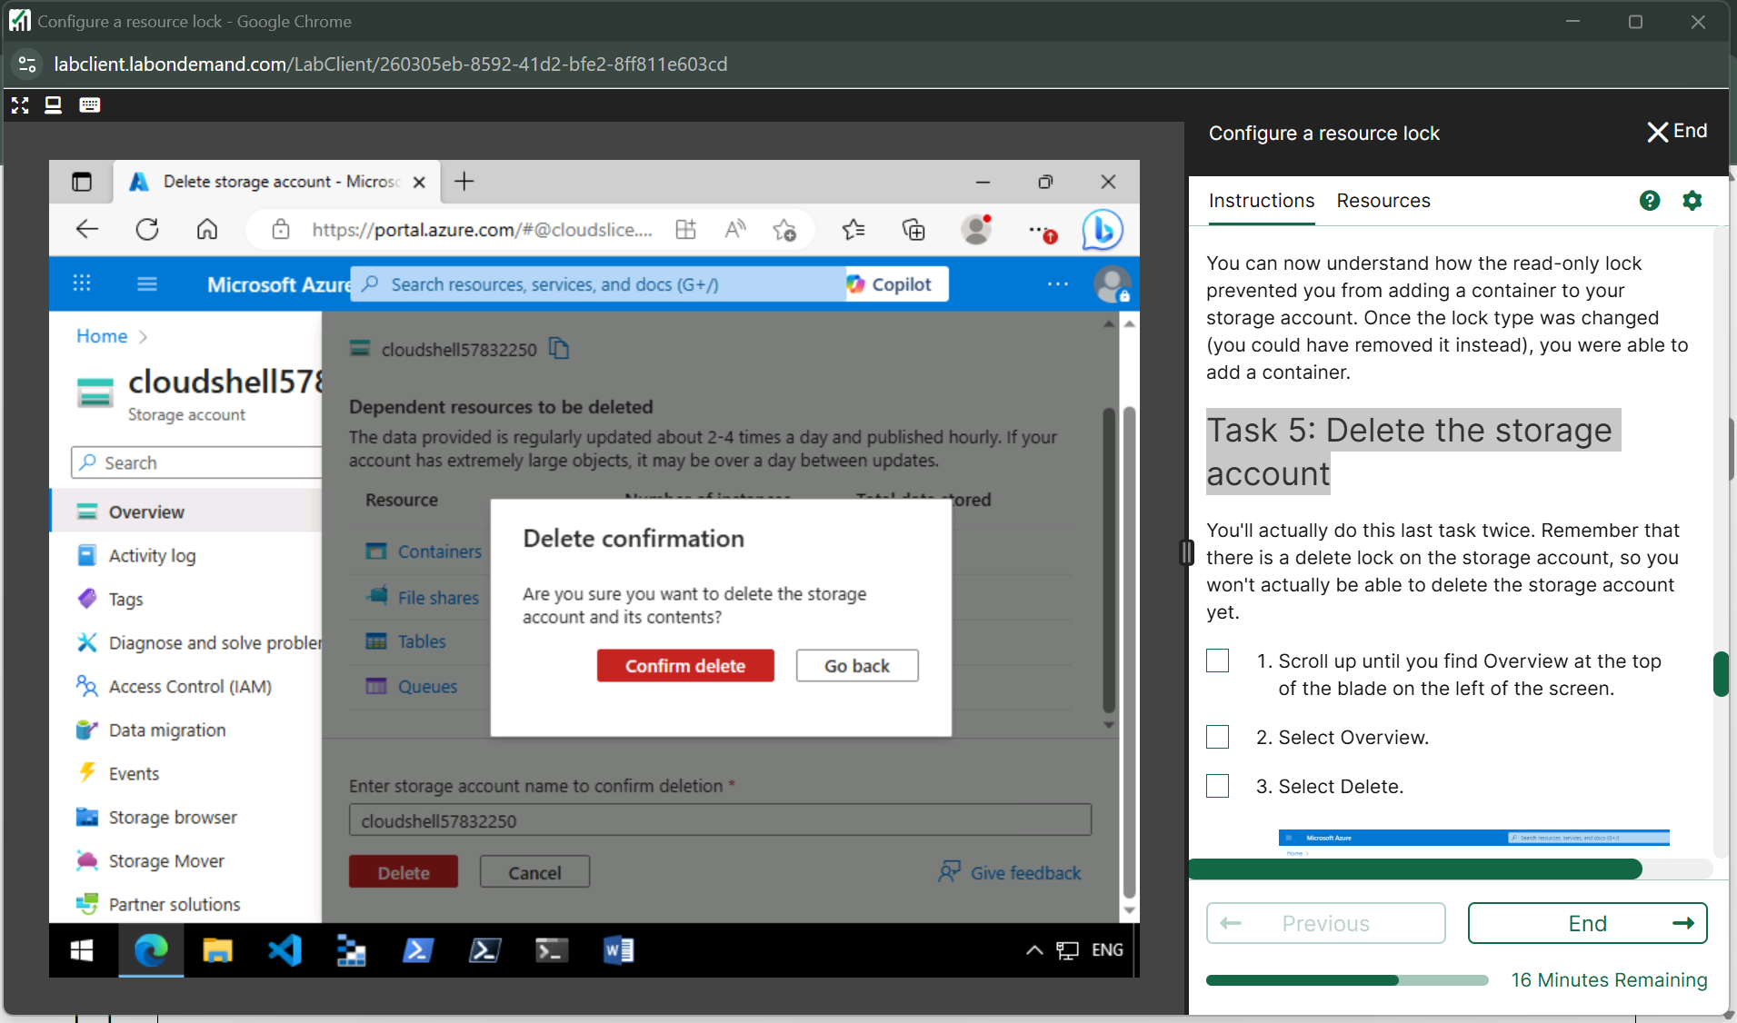

**Task 6: Remove the delete lock and delete the storage account**

